The Importance of Enterprise and the Entrepreneur in an Economy
The entrepreneur is someone who spots a gap in the market, takes both a personal and financial risk, in the hope of making a profit.
Enterprise happens when the entrepreneur spots an opportunity in a market and sets up a business to satisfy this need.
So essentially the entrepreneur is the person, and enterprise is the business idea.
Types of Enterprises
There are three main types of Enterprise:
- Financial Enterprise
- Cultural Enterprise
- Social Enterprise

1. Commercial/Financial Enterprises
The most popular types of enterprises, these are goods and services set up to make a profit. Most are owned by entrepreneurs.
`
Financial Enterprises main purposes are to:
- Create employment
- Provide services to customers and businesses
- Generate taxes that can be used to run the country
- Generate economic growth

2. Social Enterprises
Not all enterprises that are set up are set up to make money. They were set up and sometimes have paid members but their goals are not to make profit, rather their main goal is to help other people and society, such as the homeless or those in poverty. These are known as Social Enterprises.
They are not charities as they do not depend on donations, their income comes from selling goods and services, but any extra revenue generated is reinvested back into the business and the community.
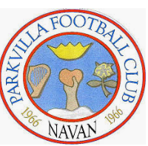
Social Enterprises main purposes are to:
- Create employment
- Provide much needed services to a community that are not being offered by the government or financial businesses
- Raise awareness of social issues
- Bring about change

3. Cultural Enterprises
Some businesses are set up to promote the arts and culture such as art galleries or music centres. Although the businesses make a profit, it is not their main aim. These are known as Cultural Enterprises.

Cultural enterprises main purposes are to:
- Create employment
- Bring in revenue to a country through tourism
- Encourage Irish innovation
- Give people access to arts and culture

The Importance of Enterprise to the Irish Economy
- Enterprise creates jobs for local people and gives higher standard of living
- Creates competition which is good for consumers
- It creates new breed of entrepreneurs, acting as a role model for others
- Supports other related businesses, e.g. provide taxis for client meetings etc..
- Government can use taxes to spend on education, hospitals etc.
- Not for Profit Enterprises provide many socially desirable places like Sports Clubs and charities.

The risks involved in setting up a new Enterprise
- You may lose money if the enterprise fails and you may end up in debt
- You may not have all the necessary skills for the enterprise to succeed
- Competition from bigger companies in a similar market
- Increased worry and stress

Environmental Impact of Enterprises
Pollution/ Waste
The production of goods and services may cause pollution- example transporting by road and air can increase carbon dioxide. Disposal of waste products into incinerators also pollutes the air. It will be important for enterprises to be considerate of this.
Planned Obsolescence 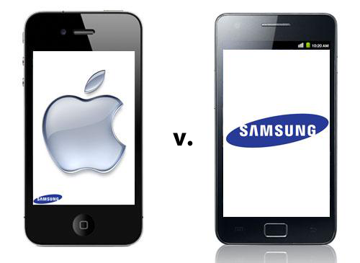
Do you ever think why Apple/Samsung release a new phone every year or why certain clothes go out of fashion?
Certain products are deliberately designed to have a short life span so that consumers buy replacements and disregard the older good. By us buying these products, more goods are thrown away and more raw materials are being used to make them.

The Entrepreneur
Remember
The entrepreneur is someone who spots a gap in the market, takes both a personal and financial risk, in the hope of making a profit.
Famous Entrepreneurs
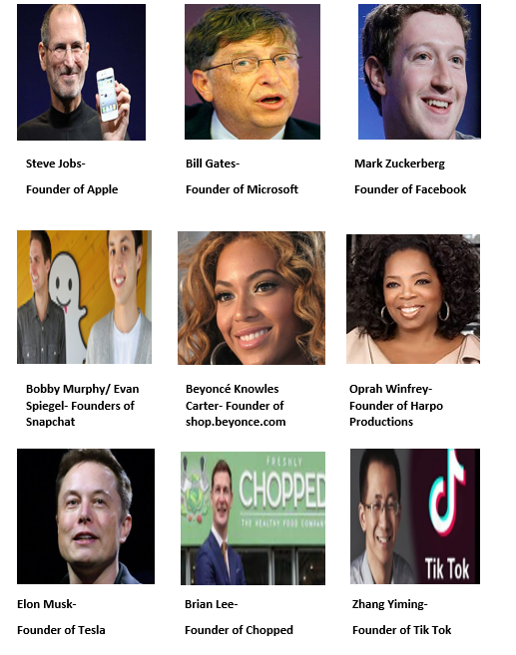
Why do People become Entrepreneurs?
People often decide to become an entrepreneur for the following reasons:
Income: Potential to make a profit and support yourself financially- to potentially earn more than an employee wage
Independence: Be your own boss, work for yourself and make all key business decisions
Challenge: Some people get bored easily and like to challenge themselves to be successful
Creativity: They have the ability to constantly come up with new ideas
Redundancy: They have been laid off from work and need a source of income for themselves

Some Key Characteristics and Skills of Entrepreneurs
Characteristics- Born with | Skills- Can learn
Creative/Innovative | Time Management
Risk Taker | Communication
Ambitious | Human Relations
Determined | Planning
Proactive | Problem Solving/Identifying Opportunities
Decisive | Stress Management
Flexible

Support for Entrepreneurs
- Enterprise Ireland funds new businesses and helps achieve global success
- Local Enterprise Office (LEO) offers advice, training and financial support to people interested in setting up a business in local communities
- Government can give grants and tax breaks

Entrepreneurship does not have to wait until you are older. Please see the link below to learn about the Student Enterprise Awards on offer to school students across the country.
http://www.studententerprise.ie/about/success-stories/

Intrapreneurship
This refers to an existing employee who act as entrepreneurs inside a business. They come up with new ideas and solutions to problem that already exist. Most businesses like Facebook and Google encourage this amongst their staff.
Let’s examine one of the most famous examples of intrapreneurship- Ken Kutaragi and the Playstation.
https://youtu.be/Y0kpYoGJE0k

Other modern examples of Intrapreneurhip
- Amazon Prime- generates billions of dollars annually

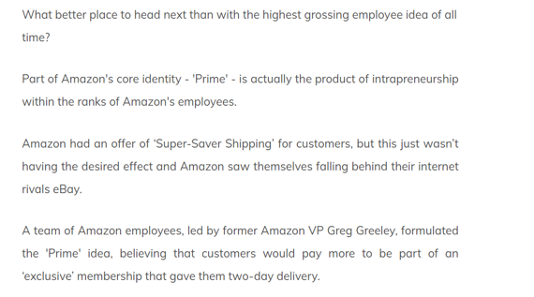
- The Sticky Note- generate 1 billion dollars annually

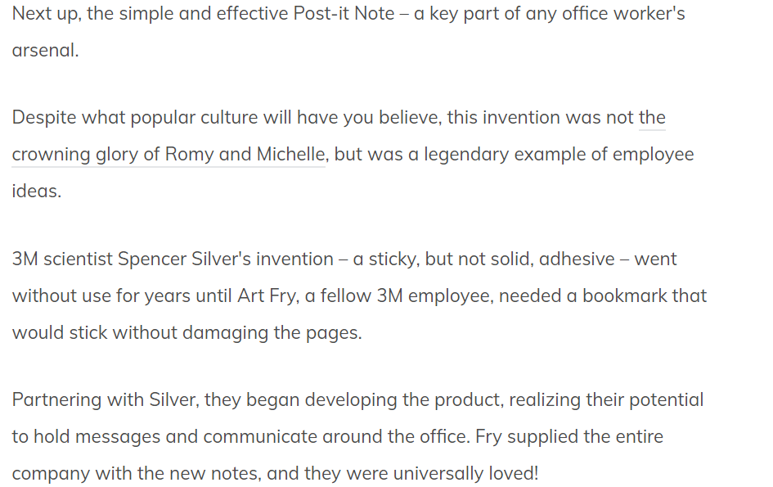

- Apple- Swipe to unlock
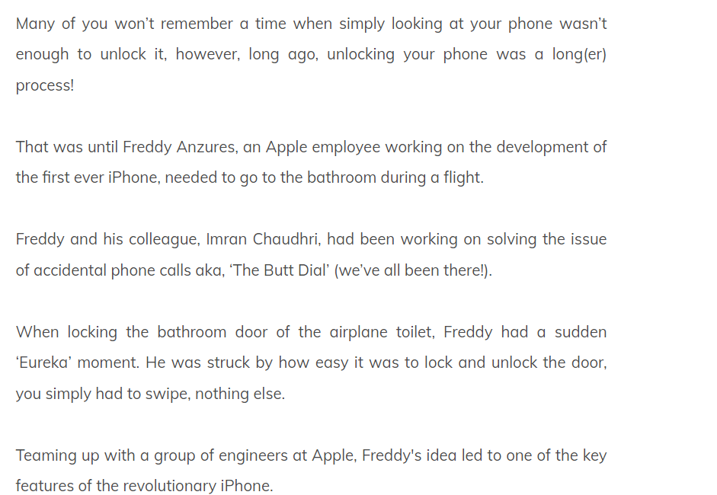

- Legoland- Waiting with children in queues

