The Importance of Advertising for Business
Advertising helps to provide information about a business, its products, qualities, and place of availability of the products and services on offer. It helps to create a non-personal link between the advertiser and the receiver of the message and the importance of an advertisement is outlined by providing:
- Information about a product
- Creation of a need/desire to have a product
- Creation of a permanent demand
- Increase in sales for the business and reduction in costs of making a product
- Reminder to users that the product is out there
- Introduce new products
- Stand out from competitors and increase market share
- Establish a relationship- e.g. get people to become brand loyal
The importance of advertisements is further highlighted by the slide below:
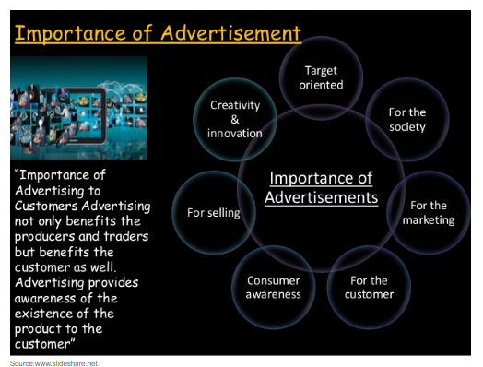

As we have seen in the Marketing Chapter, there are various forms of advertising media on offer to a business to try and reach their potential target market.
Selecting an Advertising Medium
- When will the target audience see it- Example Dora the Explorer on tv during the morning
- Nature of the product – Example Washing Powder or cleaning products being seen to work
- The Message- Trade magazines for cars
- The Cost- Depending on size of the business, what is cost effective
- Stage of the Product Life Cycle*
What makes an advertisement effective?
The following are some of the key strategies a business may use to make advertisements effective:
Demonstrate a Unique Selling Point- this product will provide you with a specific purpose that beats the competition- ‘Ryanair- the low fares airline’
Grab Attention- The use of colour, music or jingle, a story, a celebrity, mystery or intrigue can help an advertisement grab a consumers attention and make a lasting impression
Emotion- Some advertisements are very effective at pulling at our emotions- think of the John Lewis Christmas Advert or any advertisement featuring someone like Messi or Ronaldo- people want to be associated with them and be just like them
Humour- Some of the best and most effective advertisements rely on humour- this in turn will lead to people remembering the product and associating it with a positive feeling
Slogan/Catchphrase- Some advertisements use these to make the product stand out- What do you think of when you hear the brand ‘Gillette’ or ‘Head and Shoulders’??
Relatable to a Need- The product or service on offer suits the need a particular target market has and they are able to relate the product/service to their own interests
Protecting Consumers- Advertisers need to be careful
The CCPC- This is a state body set up to protect consumers. Part of its function is to outlaw that is Illegal to make false claims about goods, services, prices
The Advertising Standards Authority of Ireland
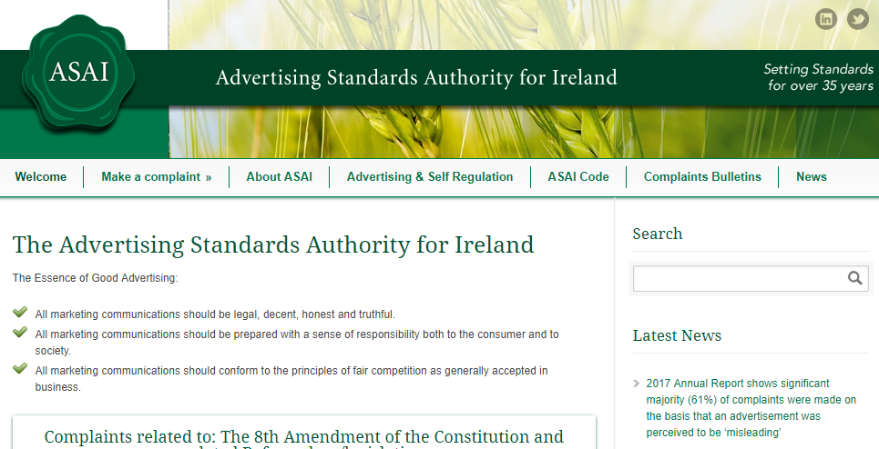
The Advertising Standards Authority of Ireland keeps an eye on the advertising industry to ensure that consumers are protected
Any member of the public can complain to the ASAI in writing. It will investigate the complaint and if it agrees with it, will ask the advertiser to take it down or change it
