Plot a Break Even Analysis from the following information for C Ltd.
Fixed Costs | €6000
Variable Costs per Unit | €3
Forecast Sales in Output | 2,000 units
Selling Price in Euro | €7

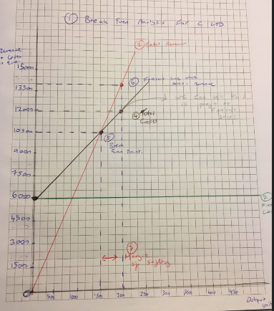
Firstly:
Find Contribution per Unit
Selling Price- Variable Costs = Contribution per Unit
€7- €3 = €4 Contribution per Unit

Find the Break Even Point
Fixed Costs/ Contribution per Unit = Break Even Point
€6000/€4 = 1500 units

Revenue and Costs Table- Learn to put like this!!
 |  | Units x Selling Price |  | Units x Variable Costs  (€3 given above) | Fixed Costs + Variable Costs | Total Revenue – Total Costs
Sales in Units | Selling Price | Total Revenue | Fixed Costs | Variable Costs | Total Costs | Profit
0 | €7 | 0 | €6000 | 0 | €6000 | (€6000)
1500 | €7 | €10500 | €6000 | €4500 | €10500 | 0
2000 | €7 | €14000 | €6000 | €6000 | €12000 | €2000

- Plotting onto Break Even Chart
Steps
- Heading of Company, Horizontal (across) axis – Label Outputs in Units, Vertical (down) axis- Label revenue and Costs
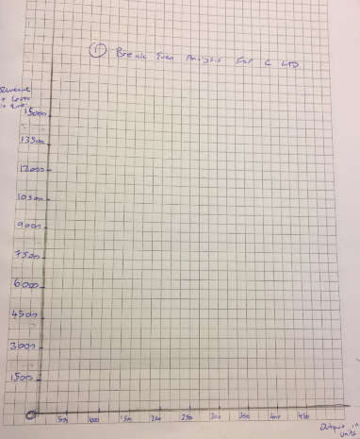

- Draw Fixed Costs line. In the question above we can see it is €6000 so we draw this on the graph.
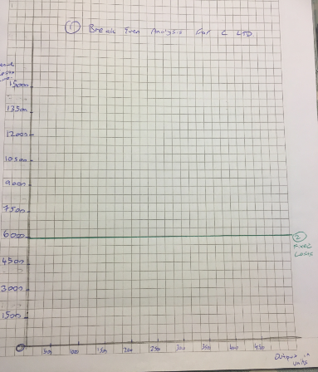

- Draw Total Revenue line and mark points. We worked these out above from the table.
(0,0) (1500,10500) (2000, 14000)
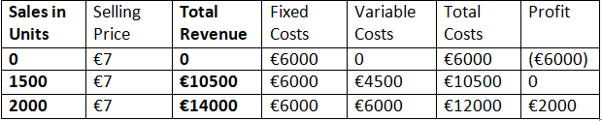

- Draw Total Costs line and mark points. We worked these out above from the table
(0,6000), (1500,10500), (2000, 12000)
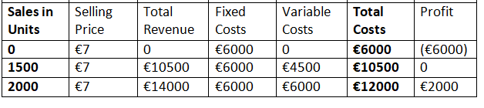

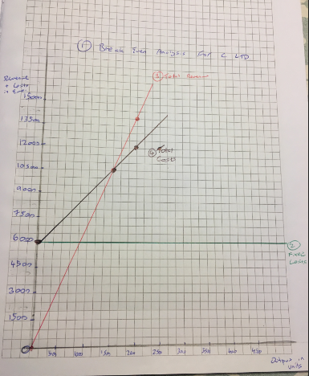

- Draw Break Even Point where Sales = Total Revenue- In this question 1500 units was equal to €10500 Revenue
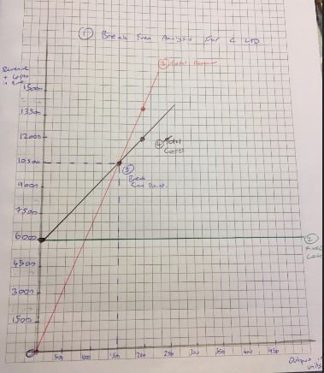

- Plot the Forecast Sales where Sales = Total Revenue. In this question 2000 units was equal to €14000 Revenue
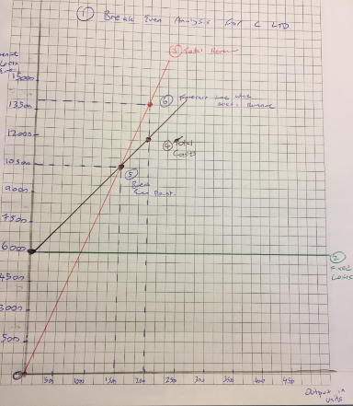

- The difference between BEP and Forecast Sales will now show us both Margin of Safety, which is 500 units, and Profit at Forecast Sales, which is €2000 (€14000 TR-€12000 TC)

