My Marketing Mix Project

My chosen product is: Apple AirPods

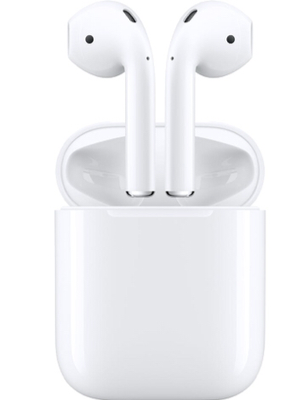

By:

Product – What are Apple AirPods?

AirPods are completely wireless bluetooth earphones. Both earpieces are separate from each other and have separate bluetooth radios. AirPods are designed to specifically fit into a right and left ear. People can move about freely when they are listening to their favourite tunes, radio or podcasts. This is very useful for people who exercise a lot, run or dance. No more wires getting tangled up !!

AirPods are designed to work with your iPhone or iPad mainly but with bluetooth you can use them with other smartphones or computers or Apple TV.

Both AirPods have advanced technology built in which can sense when the product is in your ears and have microphones for phone calls. Therefore when you take them out of your ears they stop playing. This helps to save the battery if you forget to turn them off. Handy!

How AirPods Work

Simply connect your AirPods to your device, make sure you have the volume at the right level for you, put them into your left and right ear and enjoy your music. you control what you hear with your device.

AirPods come in their own self charging case. As soon as you take them out of the case they are ready to use. The batteries are charged for about 5 hours
As with all apple products you can get your name engraved on the case. This is attractive to the loyal Apple customers.

The USP of this product is that they they come with a feature which blocks out background noise. This speaker uses two microphones and advanced apple software which removes any background noise. This allows the consumer to have a more enjoyable listening experience.

The Competition

Airpods account for roughly 60% of the wireless earphones market. The main competitors are, Samsung’s Galaxy Buds, Microsoft Surface Buds and Amazons Echo Buds.
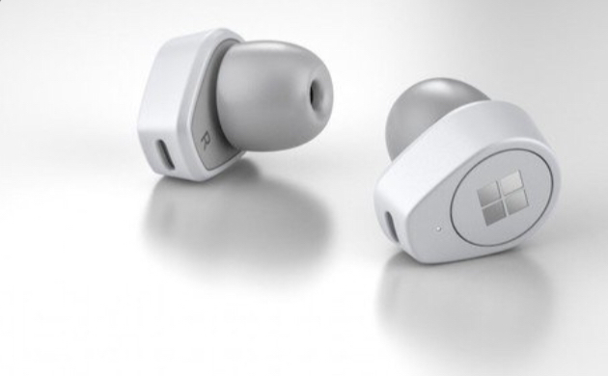
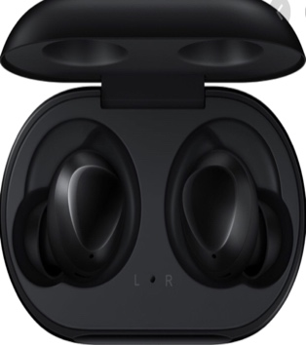
galaxy buds surface earbuds

PRICE – How much do AirPods cost?

€1 = USD $.91 as of 01.05.20

Apple online sells the standard version of AirPods ranging from in euros from 144 to 226. There are 3 generations the oldest being the cheapest.
As with all apple products you can customise your purchase by choosing a particular colour or design on it. This will increase the price of the product.

For the same 3 generations of AirPods in Currys PC World the price ranges from 169 to 270 euros as of the first of May 2020.

In DID AppleAirPods range from 169 to 279 euros. Currys and DID must be keeping a close eye on each-other!

Price of Competitors Products

Microsoft surface earbuds: €226 as of first of May 2020

Samsung galaxy buds: 2 generation’s ranging from €119-€179 as of first of May 2020.

You can see from the prices that Apple AirPods are at the more expensive end of the market. They must think their product is the best and they have loyal customers who will pay the higher price for an Apple product.
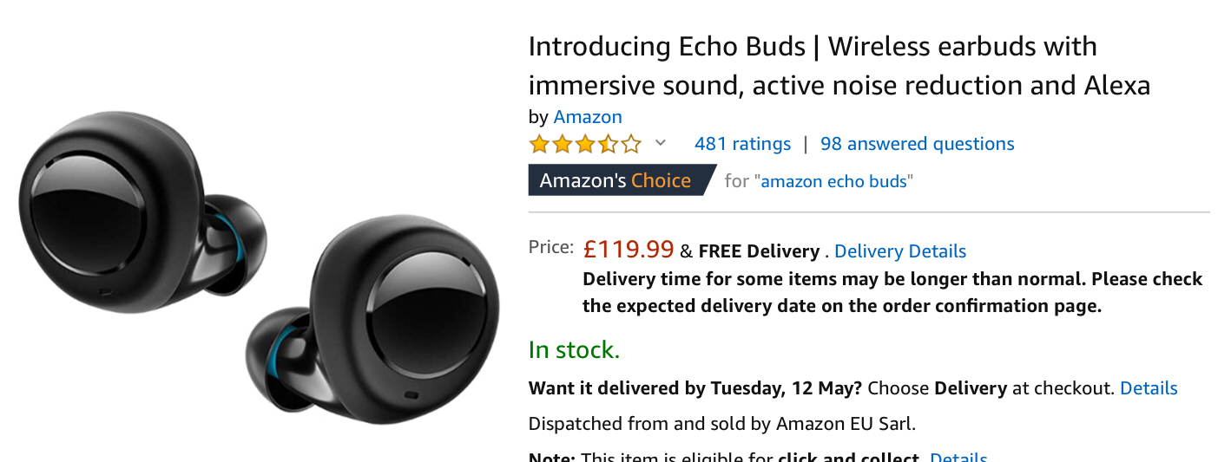
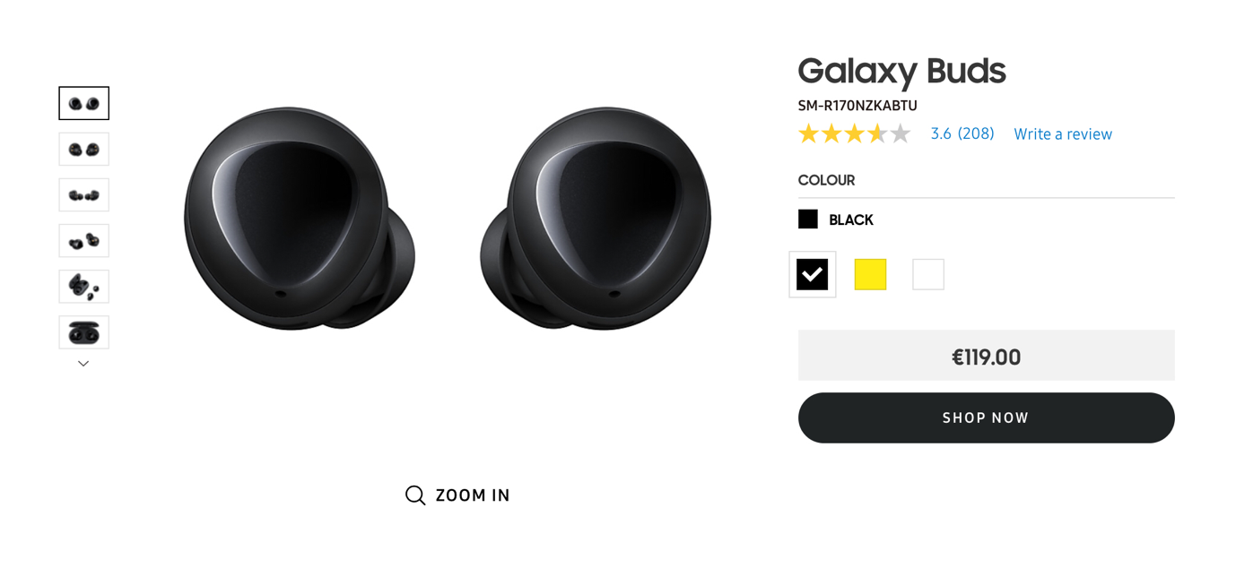

Place – Where can you buy AirPods?

Airpods can be bought both online and in store.
There is no apple store in Ireland so they have to be purchased online. Currently, because of the coronavirus, apple say delivery will take roughly 5 – 7 business days.

You can also get them in store for example at DID electrical or Currys PC world. It is handy to go in store so you can see and feel the product before buying it. However if you don’t have a lot of time you can order it online. If you buy in store you would have it straight away. In store means you can speak to an expert who knows what they are doing (hopefully) and they can give advice and show you similar products.

Buying in store is very handy. If theres any problems with the product you can go back to the shop and exercise your consumer rights by asking for refund replacement or repair of the product straight away.

If you buy online and have a problem with the product its not as convenient. In that case you usually have to repackage the product and pay money to post it back to the online store. This could a while.

Promotional

Apple airpods target market is in the more expensive end of the wireless earphone market. The age range in this market is between 15 to 45 year olds and on average per year of an air pods customer salary ranges from 35,000 to 50,000 per year.

Apple reach their customers by;

- Advertising

Apple print large images which they place on the side of buildings which advertise their products this can reach out to a large audience

- Social Media

On social media such as Snapchat, Instagram! Tik tok, Apple post videos of their new products.

- Influencers Promotional Packages

Apple send products to content creators who are popular. They promote the product by opening the package showing off whats inside trying out the product and giving their opinions of the product.
This is becoming a more and more popular way of advertising and really appears to the younger generation.

- Celebrity Endorsements

By famous and popular people wearing AirPods and being seen with them in general, this would encourage some people to buy them to have the same lifestyle as the person wearing them.

- Websites

Apple advertise all their products on their own websites so loyal apple
customers can search the website for up to date product and price information.

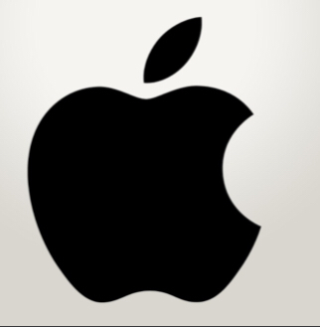

Reflections

I enjoyed finding out more about Apple AirPods. Especially because I would like a pair for myself.

I learned how companies try to sell their products and who they sell it to. I know a lot more about the features of the product now and what the competitors offer. I learned that price is not the most important thing when theres a product you really want to buy.

Also from doing this project I have learned to do a little bit of work on the project everyday even if I have a lot of school work aswell, then I can have my project done in time.

Sources

- Apple.com
- Licewire.com
- Infogram.com
- Qz.com
- Currys.ie
- DID.ie
- Amazon.com

