Financial Life Cycle
Managing my Income and Expenditure Day to Day
Unfortunately in life, we do not have unlimited access to income and must be wise when choosing our expenditure. It is therefore important to make sensible financial choices throughout our life so that we have enough money for when we need it
In Business Studies, we will learn how to manage finances properly and this will help us throughout our lives to:
- Make smart purchases and don’t waste money
- Grow our income
- Borrow wisely
- Reduce tax bills
- Understand services available from banks

As we keep a record of our income and expenditure, we usually use the money we have to spend on needs and wants
Needs: Essential items required to survive. Examples would be food and water
Wants: Items in addition to our needs, such as designer clothes, I-Pad
We must be aware as consumers the importance of our needs on wants on us, other people, and also the environment.
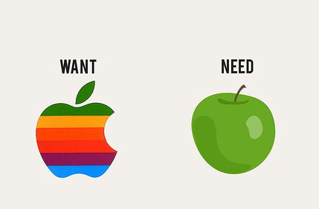
Making the most of my Resources
To understand Needs and Wants better, it is important that we understand the resources we use. A resource is anything that we can use in order to meet our needs and help us achieve our goals.
Having access to resources are far more important than owning them, for example you may have access to a school or football pitch- it is how you make the best of them that will determine their value.
There are various different types of resources which include:
Physical/Capital Resources- These are goods made by people and used to make other goods and services. Examples include houses, phones, smart devices and computers etc...
Natural Resources- These are anything provided by land or sea
Financial Resources- These are resources that allow people to buy goods and services, such as savings, loans, or any other source of income we have studies such as wages and salaries
Human Resources- These are people resources that are available to help you, such as your teachers, doctors, coaches etc.…
Time Resources- Time is a resource, which if used correctly can be maximised. For example, you only have a certain amount of time in school or college, or in certain jobs such as sports. You cannot earn or borrow more time, and so it is important to make the most of it

Financial Life Cycle
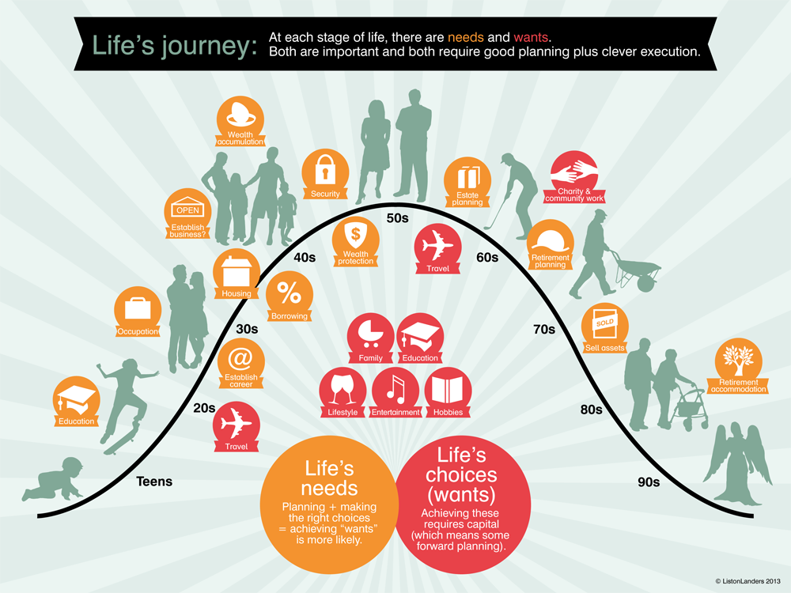
A financial life cycle is a series of stages which most people pass through during their lives. Each stage is different in terms of financial goals, income, spending, and risk
Financial Life Cycle
Stage 1- Childhood (0-12)
We live at home, our parents/guardians look after us. We have little income, other than gifts or pocket money

Stage 2- Teenage and young adult (13-20)
We still live at home, we might have additional income through pocket money/gifts or part-time jobs
Stage 3- Start a career/getting a place to live (20-30)
Most people have finished college and have their first full time jobs in their early 20’s and start to pay income tax. With regular income, you can start to buy the things you need and want. During this time, most people move out of the family home and get a place for themselves
Stage 4- Growing a career/family (30-66)
Having children and the expenses that go with that, this is usually the stage where people will earn most of their income
Stage 5- Retirement (66+)
Most people don’t work their entire adult lives and will retire. This is why having a pension plan is important- which people will have paid into during their adult working life

Task: Prepare your very own Financial Life Cycle using the Poster Paper provided. You can plan at home by speaking to family members. Please plan in class and bring with you next week.
Task criteria:
- Make sure to have the title ‘Financial Life Cycle’ centred somewhere on the page
- Include the 5 stages on your page and give a brief definition of each stage as well as age range of the individual stages
- List at least 3 needs and 3 wants for the people in these stages
- Include colour/pictures etc… to make your poster stand out

See sample pictures on the OneNote to help you.

Good Luck

