Introduction to Management: Leadership and Management

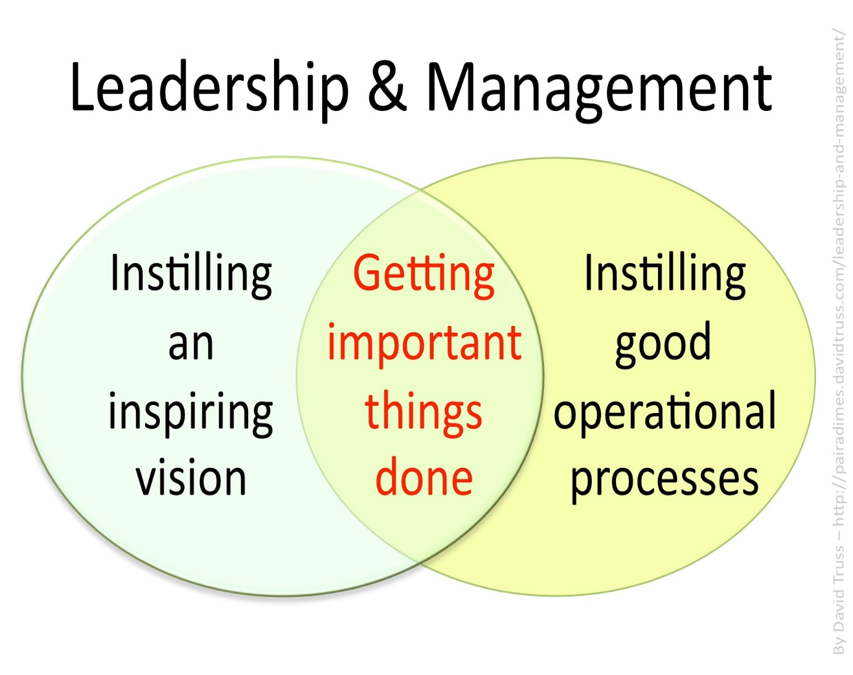

Management

Management **is the process how plans are made and resources are organised to achieve objectives.**

The management process will involve:

Management Activities

Planning---------------Organising---------------Controlling

Management skills

Leading---------------Motivating---------------Communicating

Management Characteristics



Time Management: Prioritise and delegate tasks- Example- delegate responsibility to your goalkeeping coach to work with the keepers while you sort out the rest of the team, ensure jobs get done on time, schedule and monitor jobs. This enables the business to be efficient and remain competitive

Decisiveness: Make decisions and take action if needed

Hard Working: Must be prepared to put in long hours, have a high work ethic, this will set an example for employees around them

Flexible: Capable to adapt to changing circumstances- example difficult customer, somebody needing emergency time off

People Person: Managers tend to spend a lot of time with employees, suppliers, other business owners, and customers. For this reason they need to be good with people

Differences between Entrepreneurs and Managers

|  |  |  |
| --- | --- | --- |
|  | **Entrepreneur** | **Manager** |
| Idea Genration | They are the ideas person, they spot a gap in the market. | They try and put the entrepreneurs idea in the practice. |
| Risk Taking | They ake both a personal and finacial risk. They could lose their money if the business is not successful. | Take fewer risks- if the business fails, they leave and look for a new job. |
| Running a Business | Focus on long term objectives, less time on day-day activities. | Look after day-day activities, are targets being met, delegate work to employees etc… |
| Control | Full control- do not need to consult with others. | Will have to consult with the entrepreneur before making big decisions. |

Management skills around us:

**ALWAYS LINK BACK TO:**

**Leading---------------Motivating---------------Communicating**

**In a Business**

* Be a market leader in a competitive environment
* Day to day operations- leading your staff
* Employing staff-integration into the job
* Co-ordination/delegation of duties, motivate staff to succeed
* Stock control management
* Communicate changes to the workplace

**In your Community**

* Setting up clubs and societies
* Chair and lead meetings
* Delegation of roles and responsibilities
* Communicate any changes
* Plan and organise events
* Leadership to get people involved and motivated

**In your home**

* Plan events- e.g. holidays
* Control finances- e.g. budget for shopping/bills paid on time
* Ensure jobs get done around the home and on time-Delegation
* Communication

**For the Government**

* Provide high quality services for the public
* Communicate to the public any changes
* Lead the governance of the country- e.g. Government Budget
* Motivating ministers to complete jobs for the benefit of the country

**Management Skills: Leadership**



**Leadership** is the ability to influence the behaviour and actions of others in the pursuit of certain goals through guidance, communication, and delegation. **Example- a team project leader.** It is very difficult to lead alone, and the real power of an effective leader is to have the ability to have a positive impact on the actions and behaviour of others around you.

It is very important for a leader to delegate responsibility as it will be near impossible to get all work done by themselves.

**Delegation** means the assignment of authority/power to another person. It is generally assigned from a manager to a subordinate, to undertake a specific work task or project. The accountability for the task/project is also assigned. **Example- delegate responsibility to a worker to ensure that there is enough stock on the shelves during lunchtime service.**

Benefits of Delegation

* Manager is not required to do all the work and has more time for strategic planning.
* Task/project may be completed to a higher standard due to the level of personal care
* Work gets done faster
* Accountability provided by delegation
* Increased employee motivation from job enrichment/ improved staff morale
* Good way to train employees for management

Sample Question 2021

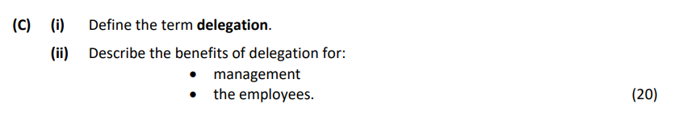

Delegation involves the assignment of authority to another person. It is generally assigned from a manager to a subordinate, to undertake a specific work task or project. The accountability for the particular task/project is also assigned.

**Manager Benefits**

Frees up time for management for strategic planning: Manager is not required to do all the work and has more time for planning towards the big picture in the future.

Increased efficiency: Task/project may be completed to a higher standard due to the level of personal accountability provided by delegation.

Work-life balance improves for the manager: Delegation may improve the work-life balance for the manager. Manager recognises the need to delegate and their workload can decrease.

Effective time-management tool: Managers can prioritise tasks that need their attention.

**Employee Benefits**

Higher skilled workforce: The tasks up-skill staff and develop employee capabilities. It allows staff to train in areas that can benefit them in future promotion opportunities

Increased motivation/staff morale: Increased employee motivation from job enrichment/ improved staff morale/more challenging work. Staff can feel valued and appreciated in their job.

**The following three leadership styles are generally used in business management:**

* Autocratic
* Democratic
* Laissez-Faire (Free Reign)

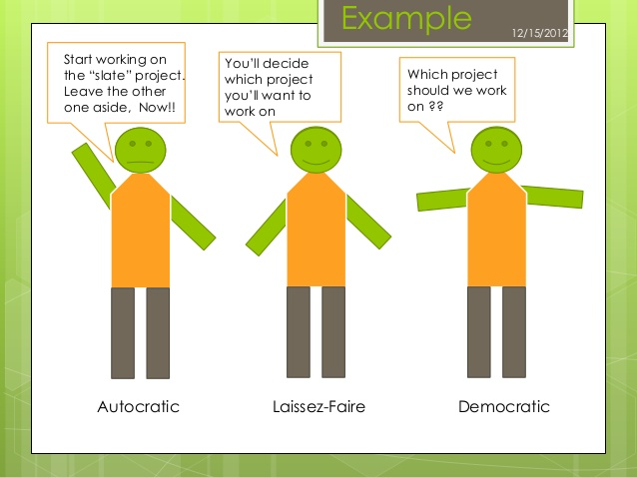

Autocratic Leader: My Way or the High Way

  

**Autocratic Leadership**- I am in Control

Autocratic The leader gives instructions to subordinates without taking their opinions on board. S/he makes decision without consulting with anyone. It is the ‘My Way or the Highway’ style of management. Example: A product recall or an emergency in store that requires a quick and instant decision.

Characteristics

• The leader gives instructions to subordinates

• Decision making is not shared/no consultation

• Little room for employee innovation

There are very few examples of this leadership style today, although it does still exist. For example, a chef in a kitchen would need to have autocratic leadership. Why?

|  |  |
| --- | --- |
| Advantages | Disadvantages |
| Quick decisions are made- only one person in control which saves time | Frustration and low morale amongst staff- they are not being heard- output will also suffer |
| Provides strong motivation and job satisfaction to the leader who can dictate terms | Higher staff turnover- a lot of staff will not want to work under this management style where there voice is not heard |
| Good in routine situations where there is little scope for innovation | Work overload for the manager and time wasted on tasks others could complete |

Democratic Leadership: Your opinion matters to me

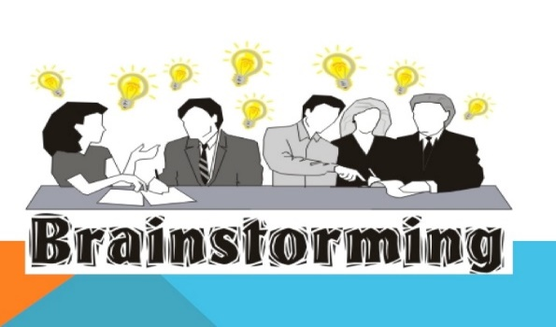 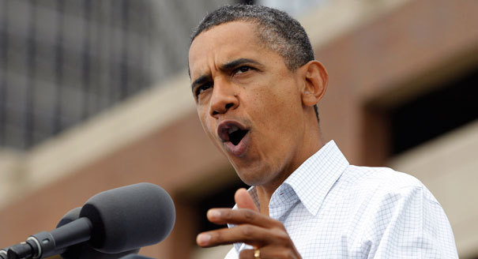

**A democratic leader involves the employees in the decision-making process. They listen to the views of others and may facilitate consensus of the team. The final decision always rests with the leader but opinions matter to them.**

**Leadership generates a sense of belonging but it is still centrally controlled by the manager/ Capitalise on the skills and talents of employees by letting them share their views rather than expecting them to conform.** Example: Google often have brainstorming sessions where the employees are free to come up with potential ideas for new products and projects.

**Characteristics**

**• The leader shares decision making with subordinates**

**• They listen to the views of employees /collaborative/keep employees informed of changes so they feel part of the retail outlet**

**• Leadership generates a sense of belonging but is still centrally controlled by the manager**

**• Teamwork-fosters an atmosphere that values information sharing/greater openness**

**• Requires trust between manager and employees**



Laissez Faire Leadership (Free Reign)-Freedom to make choices

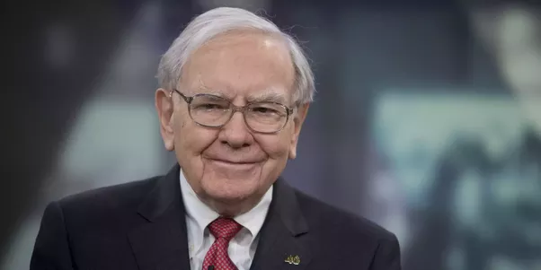

Laissez faire (Free reign) Leadership involvement is minimised/Very highly skilled employees (such as middle managers) may make their own decisions and there is no requirement for central coordination. Characteristics. Example: High tech industries such as Facebook often encourage employees to work on tasks and projects and link back in with their manager.

Characteristics

• Very highly skilled employees/experts (such as middle managers)

• This involves allowing subordinates to set their own goals and achieve them without interference of management

• Requires employees who are very engaged with their work.

|  |  |
| --- | --- |
| Advantages | Disadvantages |
| High staff morale as people feel involved in the decision making process of a business | Not suitable for everyone-some people are not good at setting their own deadlines, managing their own projects and solving problems on their own |
| Ownership of decision making for staff will lead to decisions getting maid quicker | Not ideal in situations where group members lack the knowledge or experience they need to complete tasks and make decisions |
| Encourages intrapreneurship | Lack of control for managers- perhaps targets are not being met and regular meetings needed |

Factors that influence Management Leadership Styles

* Instant/quick decisions: Where there is no need for input on the decision or where the decision wouldn’t change as result of employee input autocratic style would be appropriate
* Type of Employees: The amount of direction needed by employees will need to be considered. Assembly line staff more suited to an autocratic style
* Time: If an outcome is needed fast, a more autocratic form of leadership may be required
* Complexity of the task/Skills of employees: A more complicated task will require more detailed instruction and supervision. However, if the skill set is high, employees may require a leader to be a facilitator to allow them to figure out the task themselves.
* Corporate Culture: The culture of the organisation will also influence the leadership style expected by the manager.

Management Skills: Motivation



Motivation is a way of getting people to do something. It can encourage people to work hard and give their best in a specific role if properly motivated.

In Business, there are two theories of motivation we will look at:

1. Maslow’s Hierarchy of Needs
2. McGregor’s Theory X and Theory Y

Both of these appear a lot on the Exam- can be asked to evaluate/illustrate/outline!!

Maslow’s Hierarchy of Needs- Be able to draw, label, explain each stage

Maslow stated that people’s needs motivate them. Maslow put forward a theory on motivation based on a hierarchy of needs. As one need is satisfied then the need immediately above it on the pyramid becomes the dominant motivator/takes precedence.

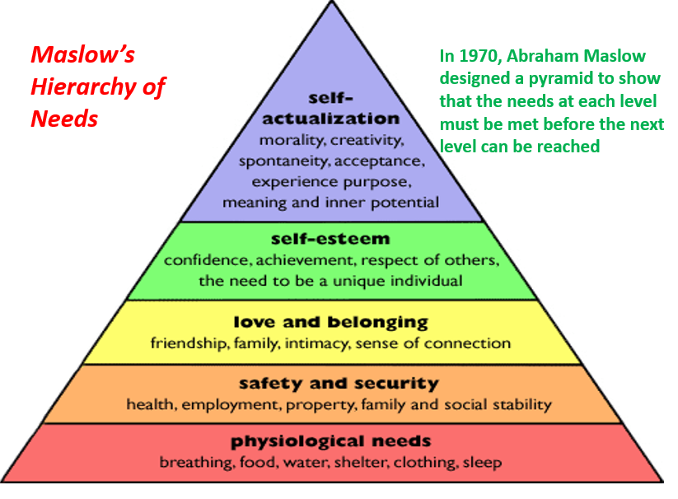

1. Physiological/Physical Needs: These are the basic needs we need to stay alive such as food and water. A worker satisfies this need by spending their wage/salary on these goods and will be motivated to work to achieve support themselves at this level
2. Safety and Security: These are the needs to feel safe and secure in our own lives. Our employers meet these needs by ensuring that we work in a safe and secure job environment

You will also start to look for job security in your position- perhaps through a long term contract as you start to look for a mortgage. For example, in teaching it is very difficult to get a long term contract and this is a huge issue in teaching today.

Or for safety, having correct goggles, equipment etc..

1. Love and Belonging/Social Needs: You begin to fit in in your job. You get along with our peers and feel part of the team. The social needs of employees can be met through offering flexi-time which allows employees to spend more time with their families. Teamwork and social events can help workers form new friendships and relationships.

For example, many businesses such as Facebook regularly have team bonding days to integrate all staff and ensure they feel part of the team

1. Self-Esteem: You now want recognition for your work- you want to feel important and valued. This can come through offering praise and rewards such as a new job title or an attractive office etc.
2. Self-Actualisation: You are fulfilling your true potential. You are motivated and are working in a job that is both challenging and fulfilling for you. Failure to know that this level is in reach may lead to demotivation amongst staff, however if you reach this stage you are being all you can be.

Limitations of Maslow’s Hierarchy of Needs

• Needs may not occur in the strict order specified by Maslow (cultural and individual differences)

• Not all employees are governed by the same set of needs

• Needs may not be all of equal value to the employees

• Employees may be driven by different needs at different times

• Theory not based on rigorous sampling

Evaluation of Maslow’s Hierarchy of Needs

**Maslow’s motivational theory is useful as it shows managers how to find suitable ways to motivate employees and develop their careers. Businesses that are able to match these needs will generally retain staff.**

**However, in real life many employees need to satisfy more than one need at a time and the needs of staff will vary. The key will be to treat staff as individuals and identify which stage each employee is at.**

McGregor Theory X and Theory Y – (Douglas McGregor 1960)

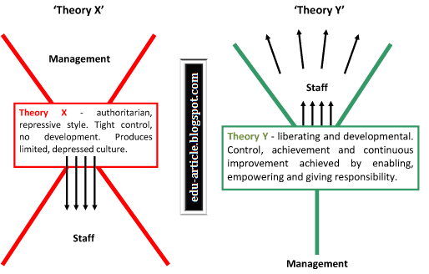

In 1960, American social psychologist Douglas McGregor developed a theory of motivation that suggests there are two opposite approaches to management: Theory X and Theory Y.

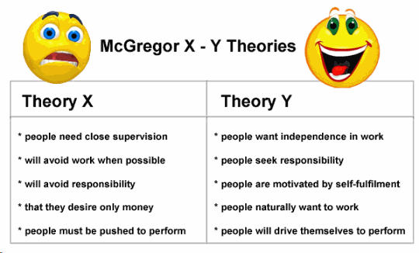

Theory X managers believe that their employees:

• Don’t like to work

• Are lazy

• Have no ambition

• Like to be told what to do

• Are only motivated for the money

**Theory X managers keep a close eye on workers and use threats and punishments to make sure they do their work or promises them more money.**

A manager who adapts Theory X approach in the workplace could have the following implications:

**• Demotivated workforce as a result of the autocratic approach, lack of consultation and empowerment. Lack of trust; no delegation; low morale**

**• High labour turnover and re -training costs for the company**

**• Industrial relations problems, impacting on productivity/output**

**• Poor time management because the Theory X manager will not delegate tasks, resulting in possible overwork and stress for the manager**

**• Low quality of work/output; low quality of goods/services; lack of incentives provided to be entrepreneurial, to do things differently, and to take an interest in the work**

Theory Y managers are the opposite. They believe their employees:

• Like working

• They have ambition

• Want responsibility

• Like more challenging work

**Theory Y managers motivates by offering promotions, praises employees and delegates work to good employees.**

A manager who adapts Theory Y approach in the workplace could have the following implications:

**• Motivated workforce who are happy in their job and it is reflected in high quality output.**

**• Low labour turnover and re -training costs for the company which is a significant cost saving that can be used elsewhere in the business**

**• Limited Industrial relations problems**

**• Workers will seek tasks and empowerment meaning manager is free to concentrate on the more important t**

**• Increased reputation in the market place which can be used to attract the best workers**

Evaluation of McGregor Theory X and Theory Y

**McGregor’s Theory X and Y is a good idea about motivation as it makes sense that in Theory Y employees will work harder and make a better contribution to the business if they are treated as responsible and valuable employees.**

**In Theory X, managers that adopt a Theory X approach could lead to poor levels of motivation in some cases as workers are not involved in decisions and are only told what to do.**

**The criticism is that there all managers can fit into just 2 categories which overall may be too simplistic but nonetheless gives an interesting insight into workers motivations.**