**Management Skill: Leadership**

**Task: Research a figure in the business world where each type of leadership is evident.**



**Leadership** is the ability to influence the behaviour and actions of others in the pursuit of certain goals through guidance, communication, and delegation. **Example- a team captain.** It is very difficult to lead alone, and the real power of an effective leader is to have the ability to have a positive impact on the actions and behaviour of others around you.

It is very important for a leader to delegate responsibility as it will be near impossible to get all work done by themselves. **Delegation** means the assignment of authority/power to another person. It is generally assigned from a manager to a subordinate, to undertake a specific work task or project. **Example- delegate responsibility to your goalkeeping coach to work with the keepers while you sort out the rest of the team in football.**

Benefits of Delegation

* Manager is not required to do all the work and has more time for strategic planning.
* Task/project may be completed to a higher standard due to the level of personal care
* Work gets done faster
* Accountability provided by delegation
* Increased employee motivation from job enrichment/ improved staff morale
* Good way to train employees for management

**The following three leadership styles are generally used in business management:**

* Autocratic
* Democratic
* Laissez-Faire (Free Reign)

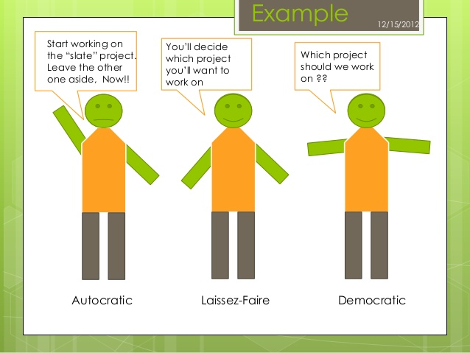

Autocratic Leader: My Way or the High Way

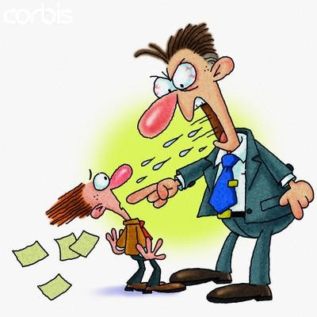 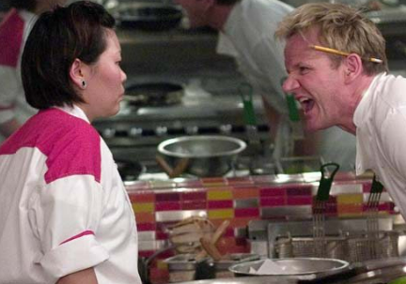 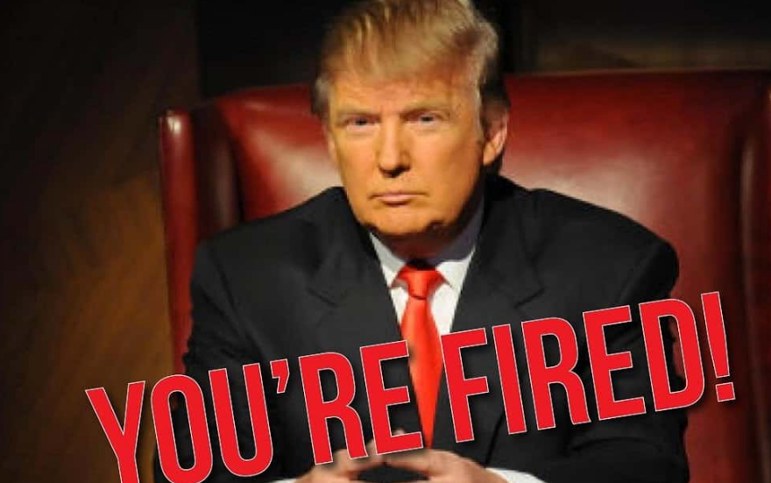

**Autocratic Leadership**- I am in Control

Autocratic The leader gives instructions to subordinates without taking their opinions on board. S/he makes decision without consulting with anyone. It is the ‘My Way or the Highway’ style of management. Example: A product recall or an emergency in store that requires a quick and instant decision.

Characteristics

• The leader gives instructions to subordinates

• Decision making is not shared/no consultation

• Little room for employee innovation

There are very few examples of this leadership style today, although it does still exist. For example, a chef in a kitchen would need to have autocratic leadership. Why?

|  |  |
| --- | --- |
| Advantages | Disadvantages |
| Quick decisions are made- only one person in control which saves time | Frustration and low morale amongst staff- they are not being heard- output will also suffer |
| Provides strong motivation and job satisfaction to the leader who can dictate terms | Higher staff turnover- a lot of staff will not want to work under this management style where there voice is not heard |
| Good in routine situations where there is little scope for innovation | Work overload for the manager and time wasted on tasks others could complete |

Democratic Leadership: Your opinion matters to me

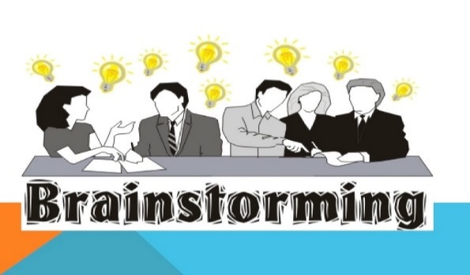 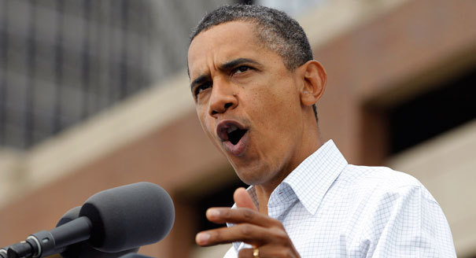

**A democratic leader involves the employees in the decision-making process. They listen to the views of others and may facilitate consensus of the team. The final decision always rests with the leader but opinions matter to them.**

**Leadership generates a sense of belonging but it is still centrally controlled by the manager/ Capitalise on the skills and talents of employees by letting them share their views rather than expecting them to conform.** Example: Google often have brainstorming sessions where the employees are free to come up with potential ideas for new products and projects.

**Characteristics**

**• The leader shares decision making with subordinates**

**• They listen to the views of employees /collaborative/keep employees informed of changes so they feel part of the retail outlet**

**• Leadership generates a sense of belonging but is still centrally controlled by the manager**

**• Teamwork-fosters an atmosphere that values information sharing/greater openness**

**• Requires trust between manager and employees**



Laissez Faire Leadership (Free Reign)-Freedom to make choices

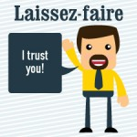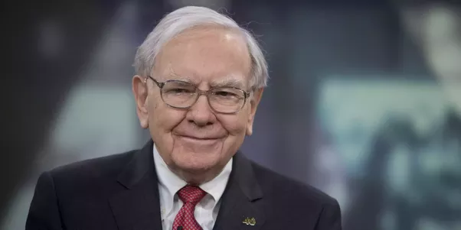

Laissez faire (Free reign) Leadership involvement is minimised/Very highly skilled employees (such as middle managers) may make their own decisions and there is no requirement for central coordination. Characteristics. Example: High tech industries such as Facebook often encourage employees to work on tasks and projects and link back in with their manager.

Characteristics

• Very highly skilled employees/experts (such as middle managers)

• This involves allowing subordinates to set their own goals and achieve them without interference of management

• Requires employees who are very engaged with their work.

|  |  |
| --- | --- |
| Advantages | Disadvantages |
| High staff morale as people feel involved in the decision making process of a business | Not suitable for everyone-some people are not good at setting their own deadlines, managing their own projects and solving problems on their own |
| Ownership of decision making for staff will lead to decisions getting maid quicker | Not ideal in situations where group members lack the knowledge or experience they need to complete tasks and make decisions |
| Encourages intrapreneurship | Lack of control for managers- perhaps targets are not being met and regular meetings needed |

Factors that influence Management Leadership Styles

* Instant/quick decisions: Where there is no need for input on the decision or where the decision wouldn’t change as result of employee input autocratic style would be appropriate
* Type of Employees: The amount of direction needed by employees will need to be considered. Assembly line staff more suited to an autocratic style
* Time: If an outcome is needed fast, a more autocratic form of leadership may be required
* Complexity of the task/Skills of employees: A more complicated task will require more detailed instruction and supervision. However, if the skill set is high, employees may require a leader to be a facilitator to allow them to figure out the task themselves.
* Corporate Culture: The culture of the organisation will also influence the leadership style expected by the manager.

**Task:**

*Research a leader in the business world that you are familiar with and examine their leadership style.*