Management Skills: Motivation
Motivation is a way of getting people to do something. It can encourage people to work hard and give their best in a specific role if properly motivated.
In Business, there are two theories of motivation we will look at:
- Maslow’s Hierarchy of Needs
- McGregor’s Theory X and Theory Y
Both of these appear a lot on the Exam- can be asked to evaluate/illustrate/outline!!
Maslow’s Hierarchy of Needs
Maslow stated that people’s needs motivate them. Maslow put forward a theory on motivation based on a hierarchy of needs. As one need is satisfied then the need immediately above it on the pyramid becomes the dominant motivator/takes precedence.

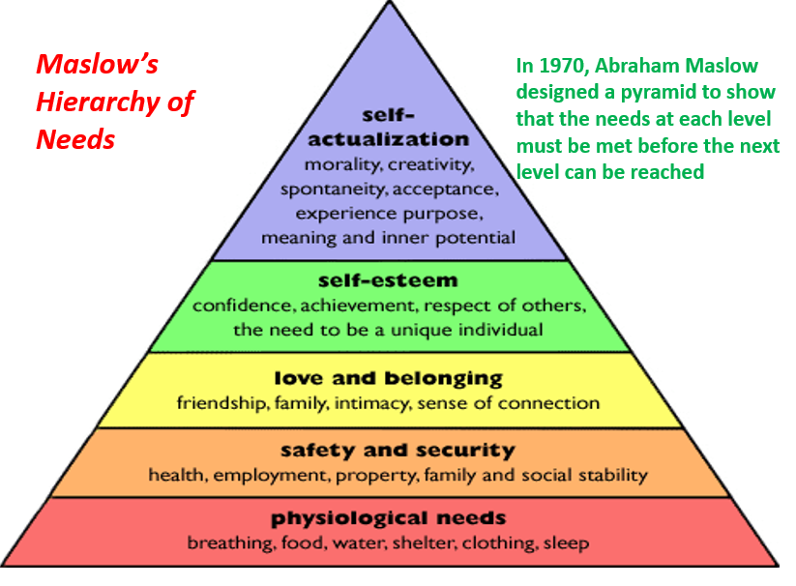
- Psychological Needs: These are the basic needs we need to stay alive such as food and water. A worker satisfies this need by spending their wage/salary on these goods and will be motivated to work to achieve support themselves at this level

- Safety and Security: These are the needs to feel safe and secure in our own lives. Our employers meet these needs by ensuring that we work in a safe environment
You will also start to look for job security in your position- perhaps through a long term contract as you start to look for a mortgage. For example, in teaching it is very difficult to get a long term contract and this is a huge issue in teaching today

- Love and Belonging: You begin to fit in in your job. We get along with our peers and feel part of the team. If you don’t have this in your job you may start to feel alone and isolated from everyone else and therefore may look to leave. For example, many businesses such as Facebook regularly have team bonding days to integrate all staff and ensure they feel part of the team

- Self-Esteem: You now want recognition for your work- you want to feel important and valued. This can come through the possibility of promotion or pay rises for work that is being done

- Self-Actualisation: You are fulfilling your true potential. You are motivated and are working in a job that is both challenging and fulfilling for you. Failure to know that this level is in reach may lead to demotivation amongst staff, however if you reach this stage you are being all you can be.

Evaluation of Maslow’s Hierarchy of Needs
Maslow’s motivational theory is useful as it shows managers how to find suitable ways to motivate employees and develop their careers. Businesses that are able to match these needs will generally retain staff.
However, in real life many employees need to satisfy more than one need at a time and the needs of staff will vary. The key will be to treat staff as individuals and identify which stage each employee is at.

McGregor Theory X and Theory Y – (Douglas McGregor 1960)
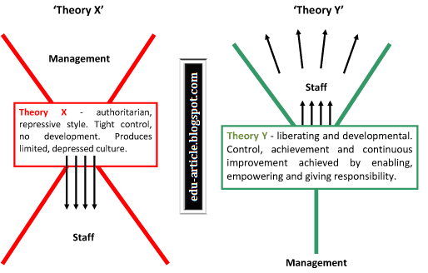

In 1960, American social psychologist Douglas McGregor developed a theory of motivation that suggests there are two opposite approaches to management: Theory X and Theory Y.
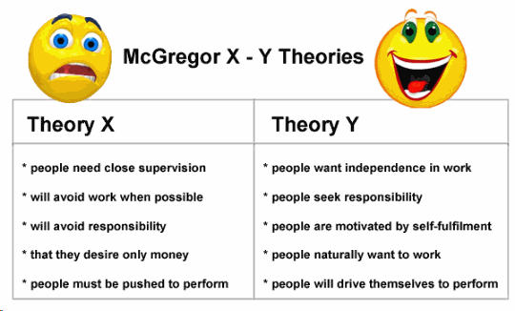
Theory X managers believe that their employees:
• Don’t like to work
• Are lazy
• Have no ambition
• Like to be told what to do
• Are only motivated for the money
Theory X managers keep a close eye on workers and uses threats and punishments to make sure they do their work or promises them more money.
Theory Y managers are the opposite. They believe their employees:
• Like working
• They have ambition
• Want responsibility
• Like more challenging work
Theory Y managers motivates by offering promotions, praises employees and delegates work to good employees.
Evaluation of McGregor Theory X and Theory Y
McGregor’s Theory X and Y is a good idea about motivation as it makes sense that in Theory Y employees will work harder and make a better contribution to the business if they are treated as responsible and valuable employees.
In Theory X, managers that adopt a Theory X approach could lead to poor levels of motivation in some cases as workers are not involved in decisions and are only told what to do.
The criticism is that there all managers can fit into just 2 categories which overall may be too simplistic but nonetheless gives an interesting insight into workers motivations.
Questions to consider
- For Maslow’s Hierarchy of Needs- apply how each stage could relate to someone who works in a fast food restaurant.
- For McGregor’s Theory X and Y- think of specific examples of when each theory may be appropriate in a business situation.
- As a worker, would you rather be seen as a Theory X or Theory Y worker by your manager? Why?
- What are the criticisms of each motivational theory?

