International Trade

Foreign trade is concerned with selling goods and services to, and buying goods and service from other countries. It involves exporting and importing.
In International Trade, Ireland is one of the biggest open economies* in the world. This is where goods and services are traded in the international community. Funds can also be transferred across borders allowing countries to borrow from another country if necessary. A measure of a country’s openness is the fraction of GDP devoted to imports and exports. Nearly 80% of what is produced in Ireland is exported.
Our open economy is positive for Ireland as it fuels our economic growth and creates lots of employment for Irish people and more choice for consumers as more goods are available in the Irish market.
Focus on Ireland- Imports and Exports
When Irish businesses sell products and services to foreign countries, this is called exporting. The good/service leaves a country causing money to come in. We as a country export for many reasons such as increasing profit margins for Irish businesses and to diversify business portfolios.
Examples of Irish exports would be Lamb, beef, Guinness. We make it here, we sell abroad, and money comes into the country.
When Irish businesses and people buy products and services from foreign countries, this is called importing. The good/service comes into a country causing money to go out. We as a country import for many reasons such as having a unsuitable climate to produce certain goods, a lack of skills, or a lack of natural resources.
Examples of Irish imports would be cars and phones. They are made abroad; we buy here, money going out of the country.
Example 1:
Produce goods/services- Export Abroad
Ireland produces and Export out of country (e.g. beef/ potatoes).
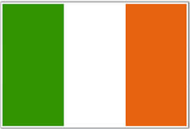 ------ 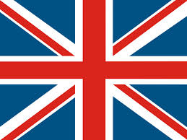 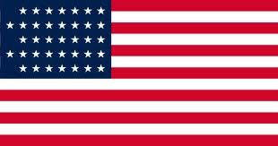 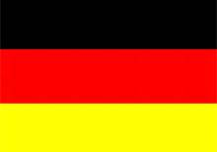
Example 2:
Produce Goods/Services Import from abroad
Foreign companies produce and we Import from abroad (e.g. cars).
-------
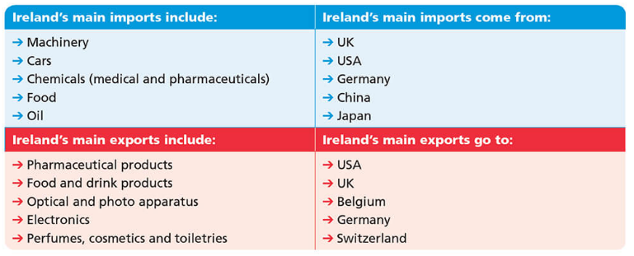
Visible Trade
These are visible products that can be seen going in and out of a country.
-Visible Exports and Visible Imports
Visible exports are goods produced by a country that causes money to come into a country. We can see them and so they are tangible. Remember: Exports are sold abroad meaning we get paid for producing them. Example- Jameson selling whiskey to U.S.A.
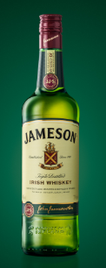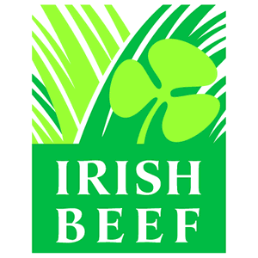
Visible Imports are goods produced by another country that need to be brought into our country. We can see them and so they are tangible.
This will cause money to leave our country. Remember: Imports are brought into a country meaning we have to buy them. Examples of visible imports would be German/Japanese Cars, an Irish shop buying oranges from abroad.
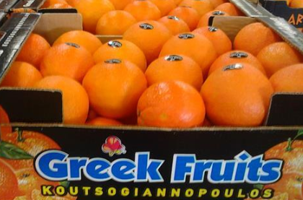
Invisible Trade
Invisible Trade deals with services. No physical product can be seen going in or out of a country. Money goes into or comes out of a country as a result of the sale or purchase of services.
-Invisible Exports and Invisible Imports
Invisible exports are services produced by a country that causes money to come into a country. Irish people produce the services and make earnings that are given to our country. Examples would be tourists using Irish hotels, or Irish artists like Niall Horan playing a gig abroad.
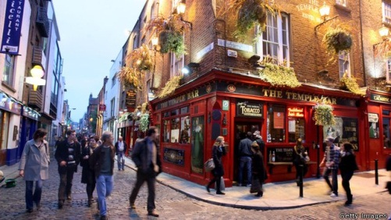
Invisible Imports are services produced by residents in a country that cause money to go out of a country. Foreign people produce the services and Irish people use them causing money to go out of the country. Examples would include Irish people going on holidays or artists such as Billie Eilish coming to perform in the 3Arena and sending the money abroad.
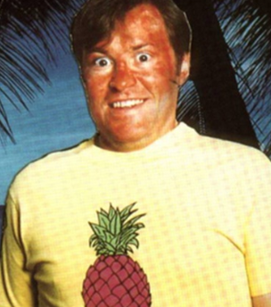
The Balance of Trade and Balance of Payments
The Balance of Trade is the difference between visible exports and visible imports. It is Visible Exports – Visible Imports
(If asked to define, include what a visible exports and visible import is with an example)
Balance of Trade
Visible Exports > Visible Imports = Surplus
Visible Exports < Visible Imports = Deficit
2016 Short Question Part A.
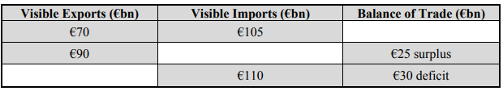
The Balance of Payments is the difference between Total Exports (Visible & Invisible) and Total Imports (Visible & Invisible). It is the total amount of money entering and leaving a country during the course of a year.
It includes the Balance of Trade plus the Balance of Invisible trade.
Balance of Payments
Total Exports > Total Imports = Surplus
Total Exports < Total Imports = Deficit
Correcting the deficit
If a country’s balance of current account is a deficit this can be overcome by either increasing exports or decreasing imports.
Increasing Exports: This would require countries to increase the amount of products produced in a country that can be sold abroad. State owned companies such as Enterprise Ireland provide grants to help Irish firms expand to new markets.
Decrease Imports: This would require a country reducing the amount of products brought into the country and in turn implement an IMPORT SUBSTITUTION* policy, which involves replacing imported goods with domestically produced products.
John Stafford in Wexford based Slaney Farms has created a baby potato to rival any imported French or English Baby potato. The skin finish is clean and bright with perfect eating quality to replace the imported products.

We will practice questions and calculations on the Balance of Trade and Balance of Payments from the textbook and Exam Papers.
*The Significance of International Trade to the Irish Economy*- also can be asked as benefits of International Trade for Irish (indigenous) companies
- Increased Sales and Profits
The Irish market consists of only 4.7 million people. Through international trade, Irish businesses can sell their products to billions of customers all over the world. This leads to increased sales and profits.
- Economies of Scale
Making more products to export to the world gives economies of scale to Irish businesses. This means that the more money that make, the cheaper it becomes to make each product. This makes Irish products cheaper to make. This would mean inflation would decrease in an economy
- Foreign Currency
When Irish businesses sell goods to non-euro countries, they receive foreign currency. For example, when we sell goods to the USA, they pay us in dollars. This foreign currency is important because, with it, we can pay for the foreign products we need to import.
- Increased Employment
Increased sales arising from engaging in international trade means that businesses have to hire more employees. Thus, international trade leads to job creation in Ireland.
- Low Prices
Irish businesses face a lot of competition from foreign firms. This forces them to keep their costs low and their prices low so that they can compete. Dunnes Stores keep its prices low to compete with LIDL and ALDI
- Bigger choice for Consumer
Some countries want to give their consumers more choice over the products they buy. So, even though Ireland produces more than enough potatoes, we can still buy potatoes from many countries in our shops.

Free Trade and Protectionism
Free trade* means that countries can buy and sell products with other countries without any barriers or restrictions placed in their way. The countries in the EU practice free trade with each other. Buyers and sellers from different economies may voluntarily trade without a government applying tariffs, quotas, subsidies or prohibitions on goods and services.
Protectionism* involves Governments protecting their home industries from foreign competition by erecting barriers to trade e.g. tariffs, quotas, embargoes, paying subsidies to home industries. Protectionism measures are put in place to reduce imports and/or make them more expensive, to protect jobs, protect specific industries and to improve the balance of payments.
Barriers to Trade
Quota:
This is a physical restriction/limit on the number of units of a good that may be imported/exported. Quotas discourage imports and/or encourage sales of domestically produced goods.
Example: The EU has placed a quota on the amount of clothes from China that can be imported into the EU.
Tariff:
This this a tax on the value/price of goods imported. As a result, imports will be more expensive and they will be less competitive on the domestic market.
Example: A tax, duty or tariff on New Zealand beef.
Embargo:
This is a total ban on the import of goods from one particular country. It is often done for political reasons.
Example: The American government placed a blanket embargo on the import of UK beef because of the high levels of BSE in the UK.
Subsidies:
These are grants and payments made by national governments to domestic firms to help them with their day-to-day operating costs allowing them to become more competitive/to give them a price advantage over imports.
Example: The EU has subsidised agriculture and aircraft manufacturing in the past protecting them from rival non-EU competition.
Administrative regulations:
Such as customs delays, excessive paperwork designed to exclude imports.
Trends in international trade
Deregulation of International Trade*
The reduction or elimination of government power in a particular industry/ It involves removing legal barriers to entering an industry. It usually creates more competition within the industry. An increase in competition should lead to an increase in efficiency and lower prices.
The EU deregulated the airline industry to allow more competition due to the removal of monopolies and more choice for consumers/value for money. It resulted in the emergence of low cost airlines such as Ryanair.
Emergence of Trading Blocs*
A Trading Bloc is a group of countries that organise a free trade area, common market or customs union in order to reduce or eliminate barriers to trade, e.g. European Union, NAFTA (an agreement between North America, Canada and Mexico). Trading blocs agree a common set of tariffs on imports from countries outside the trading bloc.
Globalisation
The increasing number of global businesses that operate throughout the entire world. e.g. Coca Cola Could wipe indigenous businesses out with competition but also aid them in buying materials.
Brexit
Brexit poses a huge challenge for Irish businesses- they face tariffs for exports to the UK under World Trade Organisation rules, unless an agreement for trade is in place. This would make Irish products more expensive abroad
Improvements in ICT
Many businesses are using the Internet for international trade. They can sell their products all over the world on their website without having to set up shops all over the world. Customers everywhere can see and buy the business’s products from its website
Competition/Emerging Markets
Irish businesses are facing increased competition in markets such as China for low skilled products which means they may not be able to sell similar products there. However, the opportunity to develop and export skilled labour and products to new markets also increases
Opportunities for Irish Businesses for International Trade
Changes in technology
Technology has had a positive impact on Irish exporters making communications easier and instantaneous worldwide. Irish businesses can buy and sell online 24/7 to countries all over the world and the internet also allows them to market their goods to every country online.
Increased Sales
Ireland’s membership of the European Union allows Irish businesses to sell their products and services anywhere in the EU without any barriers to trade.
Furthermore, deregulation by the World Trade Organisation has removed many worldwide barriers to trade and allows for freer international commerce.
Diversification
International Trade gives Irish businesses the opportunity to spread risk as they will not rely solely on products in the Irish market. Economies of scale are made possible in the context of larger markets which should increase the competitiveness of business
English
Irish people speak fluent English. English is the international language of business.
This means that all Irish people can automatically converse with other businesses worldwide in the International language of business. This helps Irish businesses to do business more easily abroad.
Educated Workers
Ireland has a well-educated workforce. Most young people go to college. Many study science. Their excellent education helps Irish entrepreneurs invent new products that can be sold all over the world to make a lot of money for Ireland. Our biggest “knowledge-based” exports are medicines, chemicals and computers.
Green Image
Ireland has a good image around the world as a clean, green and unspoilt country. This makes it easier for us to sell food to other countries as they can trust our food to be of top quality. It also helps to attract foreign tourists. Both these industries bring in billions of euro to the country.
Challenges for Irish Businesses for International Trade
Language Barrier
Although English is the international language, it is not the world’s universal language and many firms will tend to deal in their own language. The name of a product may have to be changed; a business website may also have to make their website available in different languages.
Exchange Rate Problems
Exchange rates fluctuate, for example if the Euro strengthens against the US Dollar, Irish exports become more expensive which may lead to a decline in sales and thus a decline in profits
Distribution Problems
Ireland is an Island. This makes transporting goods more difficult and more expensive for Irish businesses. Goods can only be exported from Ireland by ship or plane. However, the goods can be transported only according to shipping and airline companies’ timetables and the weather.
Competition from Low-Wage Economies
The rate of pay in Ireland is still considered to be quite high. Other countries have much lower wages and therefore their products are always cheaper than Ireland’s. It is almost impossible for Irish manufacturers to compete against these low-wage economies.
Globalisation*
The growth in Globalisation and global companies with their quality produce at competitive prices are a challenge for Irish exporters. Irish exporting companies will have to become more efficient and invest in R&D in order to provide products with a unique selling point (USP) to survive the competitive threat from global companies.

Role of ICT in International Trade
New Information and Communications Technology (ICT) has made it easier and cheaper for businesses to engage in international trade.
ICT has many benefits for international trade:
1. Increased sales- sell online, customise products online
2. Faster and Cheaper Communications- email /Skype
3. Decision-Making- so much information available online
4. Reduced Costs- no need to travel- Skype
5. Advertising- develop a global brand through website
Government help for Irish Exporters
Enterprise Ireland
Enterprise Ireland helps Irish firms to export their products by providing:
- Market research information on opportunities in foreign countries
- Low-cost loans to Irish businesses to help them export
- Grants to help them export
Department of Enterprise, Trade and Employment
This government department helps Irish businesses to export their products by:
- Giving advice on the documents used in foreign trade and in the regulations that must be obeyed
- Providing Export Credit Insurance for industries. This is where the Irish government promises to pay the Irish exporter if a foreign customer does not pay them
Diplomatic Services
The Irish Diplomatic Service helps Irish exporters by:
- Promoting Ireland abroad to maintain and increase exports
- Put on trade fairs of products in foreign countries
- Lobby foreign governments to trade with Ireland

