Factors of Production and Categories of Industry

A combination of four basic Factors of Production are needed by all businesses while attempting to produce goods and services.
The 4 factors of production are:
- LAND
- LABOUR
- CAPITAL
- ENTERPRISE
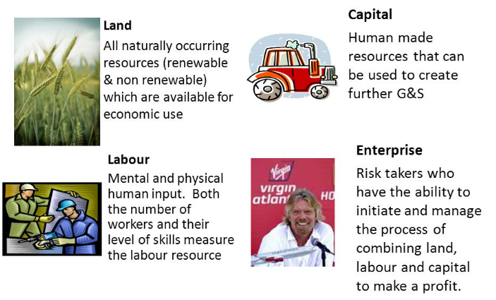
- Land: Anything provided by nature that helps to produce the good or service. Payment made to suppliers of land is rent. Examples of land items would be
- Agriculture- Farming crops.
- Fishing
- Mining
- Oil Production
- Climate- Think of sunny holidays or snow for skiing. Many countries use the weather as a natural resource to attract tourists
For example, Cadbury’s use milk to make chocolate such as Dairy Milks. The milk is the land.
- Labour: This would be any human effort that helps to produce the good or service. Payment made to suppliers of labour is wages. Examples of labour would be:
- Teachers
- Dentists
- Doctors
- Sales Assistants
- Carpenters
For example, the factory workers who use ingredients such as milk to create chocolate is labour.

- Capital: Anything made by humans that are used to assist in producing the good and services. The money invested by the business is often loaned from a bank to buy the good and services that are used in this production. Therefore the people who loan the money receive interest on repayments. Thus, the payment for capital is interest.
Examples of capital would be:
- Trucks
- Computers
- Machines
- Factories
For example, the machines used to in the production process to turn the ingredients into the final product is Capital.

- Enterprise: This is the special form of human activity that organises the other three factors of production and bears the risk involved in production. Think about products that go through a process and then end up on Dragons Den. The payment is profit/loss.
- Bill Gates- Microsoft
- Joe Murphy-Tayto
For example, Cadbury’s selling the finished product to the market.
Categories of Industry
Industry in Ireland can be classified under three headings:
- Primary- The Extractive Industry using natural resources- 5/6% of Economy
- Secondary- Manufacturing and Construction Industry-24/25% of economy
- Tertiary- Service Industries- Irelands most popular sector, with over 70% of employment.
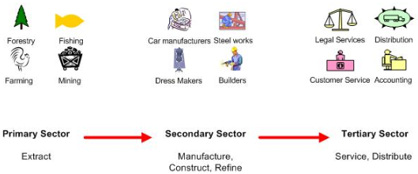
We have to note that the effects of Brexit, Covid-19, and Inflation have had have huge implications for the different sectors in Ireland’s economy in 2022.
Primary Sector
Primary producers take raw materials/natural resources from the land or sea to make a product.
The main industries involved in primary production are:
- Agriculture
- Forestry
- Fishing
- Mining
- Oil Production
Some of these materials are used in their raw state, but most are passed onto the secondary sector for production. This increases its importance to the Irish economy in trying to minimise imports and maximise exports as well as providing employment.
The primary sector trends:
- Brexit- Loss of the Britain for the EU equates to approximately 66 million people or 12.85%. This will bring with it trade issues in sectors such as farming, fishing etc… Could lead to an increase in demand for Irish produced products, shortage of supply of certain products/services
- Covid 19- The effect on demand for Irish produce as meat factories closed in certain areas, lockdown of restaurants, some business’s that would have sourced primary products did not reopen, increase in demand in supermarkets (20% surge in demand for products supermarkets, shortage of supply of certain products/services
- Inflation- Increase in costs of producing goods/services passed onto consumers, material shortages in the market, shortage of supply of certain products/services
- EU milk quotas have recently been abolished. Dairy farmers in Ireland are now free to produce as much milk as they can which enables Ireland to export more in emerging markets such as Africa and Asia
- Ireland exports 90% of its beef output, making it the largest exporter of beef in the EU and one of the largest in the world
- Ireland has green image worldwide, and with the increase demand for organic food from consumers both in Ireland and around the world, more and more farmers markets and setting up providing organic food to meet this demand
- Extracting natural resources helps reduce dependence on foreign oil, for example wind farms are becoming more common in Ireland, harvesting wind and turning it into electricity
Secondary Sector
These manufacture and process the raw materials supplied by the primary producers.
Some examples would be:
- The Building Industry
- Technological and Pharmaceutical Firms
- Food Processing
- Clothing
The manufacturing sectors in Ireland include:
Agri-business- These take farm produce and transform it into food for consumers. By processing raw materials from the primary sector, a manufacturer adds value to the goods and creates jobs in the industry. The agribusiness in Ireland exports over 50% of its output.
The sector employs 50,000 people and supports a further 60,000 indirect jobs in all parts of the country. This represents over 5% of total employment nationwide
Example- Denny buy pigs from farmers to make rashers
Indigenous Firms- These are Irish businesses set up by Irish people to make their products here in Ireland
Example- Lilly O’Briens make chocolate here in Ireland
Construction Industry- Provides Ireland with housing, businesses and infrastructure. It is a very labour intensive industry. In 2021, there is still a massive demand for houses, but Covid-19 has slowed construction
Transnational/Multinational Companies- These are foreign businesses that come to Ireland to manufacture products here.
Example- Dell manufactures computers in Leixlip, Co. Kildare.
The Secondary Sector Trends:
- Brexit- A drop in demand for Irish products may impact on jobs in this sector as UK one of Ireland’s main trading partners
- Covid 19- Many meat factories had to close, restrictions on people working in this sector, a huge amount of workers cannot work from home
- Inflation- Prices of houses rise but demand remains the same, consumer spending may have impact on demand for jobs in sector.
- Huge demand for construction workers- cannot meet demand at present
- Manufacturing creates a lot of employment in Ireland. These jobs result in fewer people claiming social welfare payments and more income tax for the government. However, the manufacturing industry is becoming more capital intensive, meaning more jobs for machines and less for people
- There is increased competition to indigenous producers, the likes of Aldi and Lidl give consumers choice to shop around meaning Irish made products will suffer
- Competition from low wage countries, together with demand for wage increases in Ireland, led to the closure of many Irish manufacturers who move their businesses to low wage economies for cost saving
The Tertiary Sector
The Tertiary sector is businesses that provide a service in an economy. They do not make products or work in the manufacturing sector.
Examples include:
- Insurance
- Banking
- Doctors
- Solicitors
The service industry is by far Ireland’s biggest employer- and thus is where most of the tax needed to run a country comes from. Ireland also exports billions of euro worth of services such as software, improving our balance of payments, and the Irish workforce is seen around the world as very well educated which attracts foreign businesses here to set up their operations.
The Tertiary Sector Trends:
- Brexit- Negative impact on exports of goods and services to the UK as more expensive and added cost for consumers to import from the UK
- Covid 19- Sector of the economy most hit, huge number of jobs lost in hospitality that have not been filled since reopening, many people working from home- change to employment legislation with the right to request to work from home in 2022
- Inflation- Consumers have less spending power, need to make choices in shopping and this can have knock on effect, increase in wage demands from workers to meet rising inflation
- Increased taxes such as Propery Tax has meant consumers have less disposable income, as demand for goods and services reduce, the amount of retail service providers close down
- E-Business is becoming increasingly popular, more and more consumers are switching to online shopping to meet their consumer needs. You can do your grocery shopping in the likes of Tesco for example without leaving your home
- High Rents- increased cost of renting for both business and workers, lots cannot afford big cities like Dublin and so may need to get higher wages or move elsewhere, this can make business less competitive in the market
- Poor access to technologies/e-commerce- not everyone has access, particularly in rural areas

