Chain of Production and Channels of Distribution
The Chain of Production
The Chain of Production refers to the various production or processing stages that a good or service goes through before it is sold.
From this we can identify 3 distinct sectors involved in the manufacturing and distribution of products.
- The Primary Sector (Raw Materials from land/sea)
- The Secondary Sector (Manufacturing/ Construction)
- The Tertiary Sector (Services Providers)
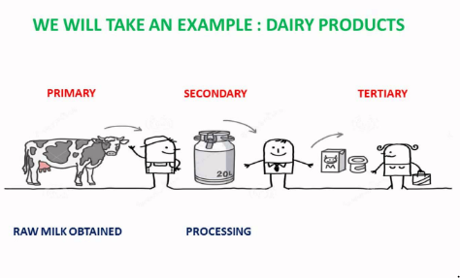
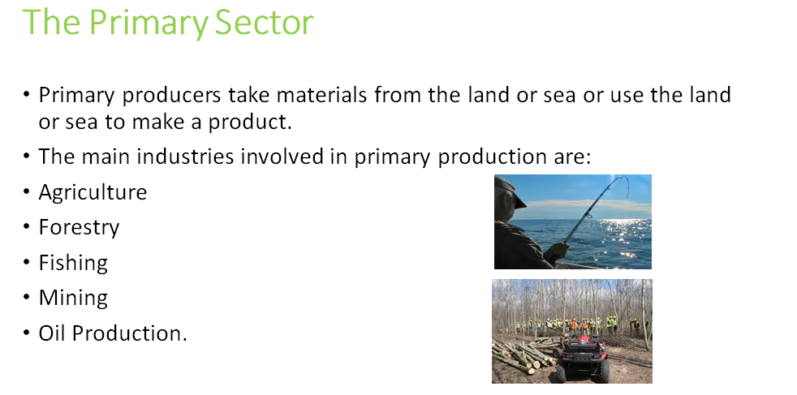
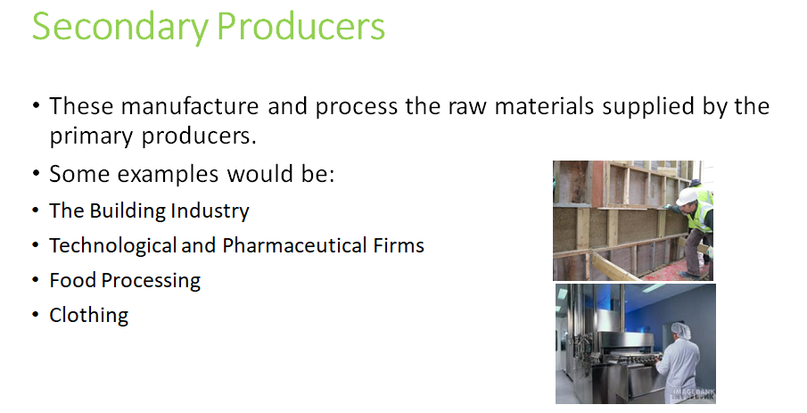
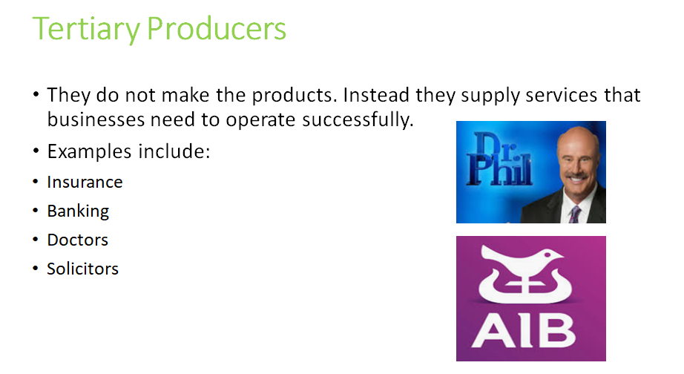
Activity: Can you match the following jobs to the relevant sectors?
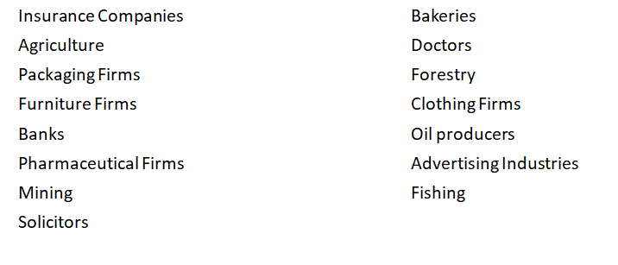
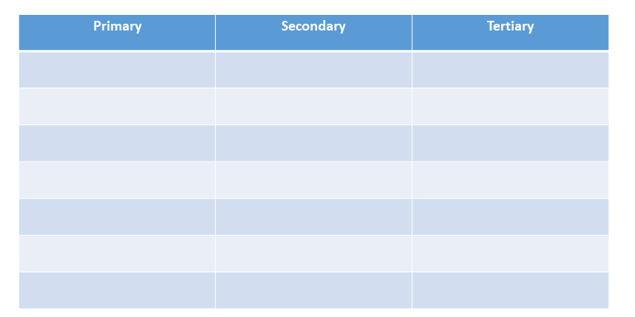
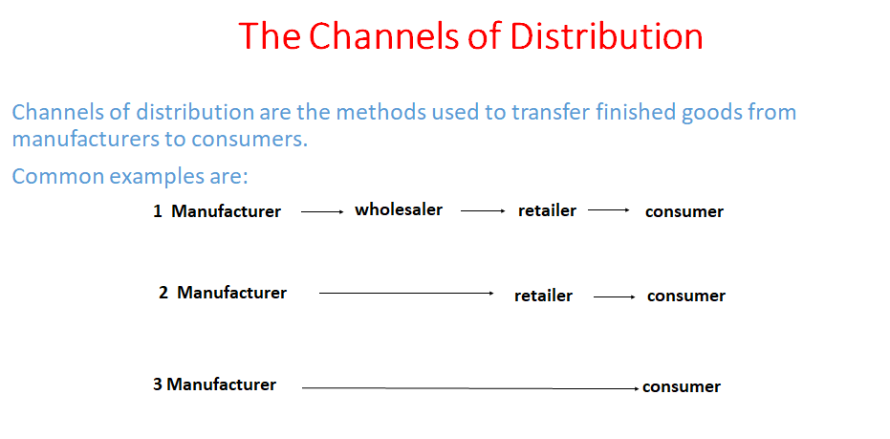
*A wholesaler is a company or person that buys large quantities of goods from many manufacturers and sells them in smaller quantities to retailers. E.G. A school may need large stocks of paper, which it purchases directly through the wholesaler in order to receive a discount
