Business Finance
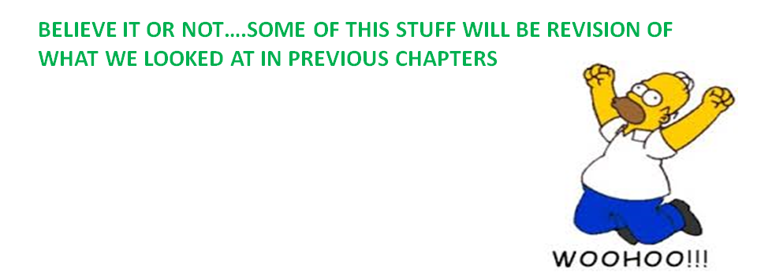In this chapter, we will examine:
- Types of Finance
- Why a business needs Finance
- Debtors v Creditors
- What a business needs in applying for a loan
- Sources of Finance
Types of Finance
(Recap from the Borrowing Money Chapter)
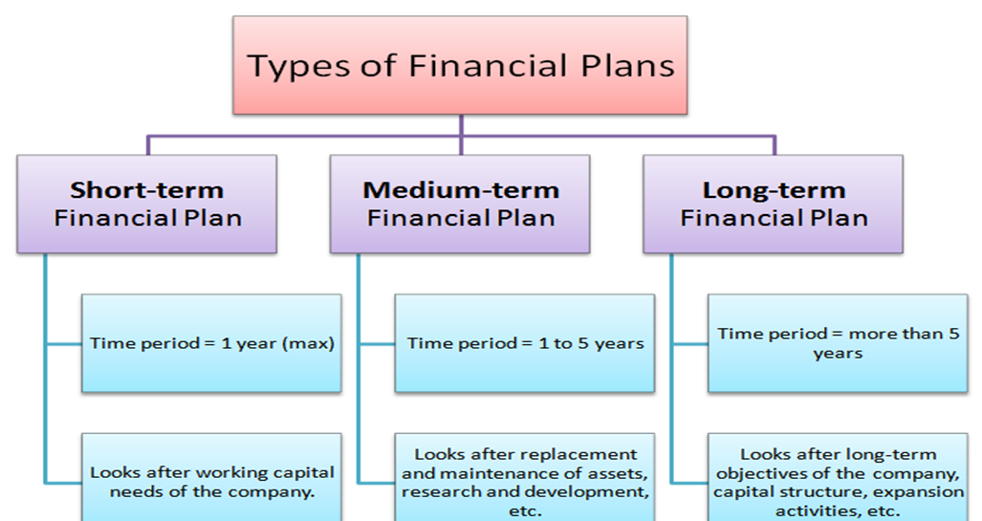
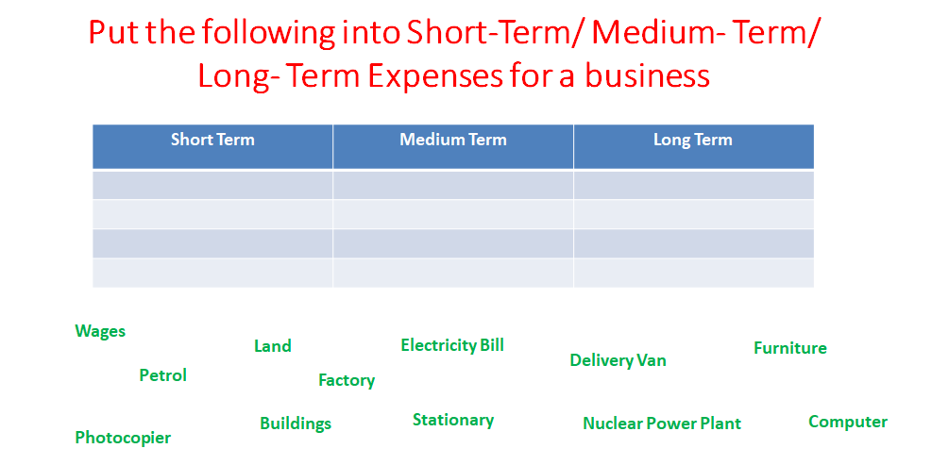
Why does a business need finance?
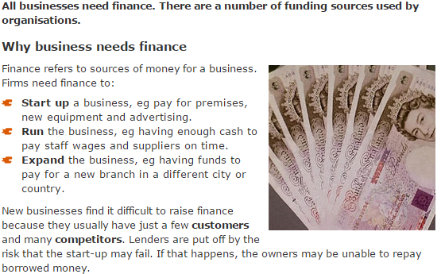
Debtors v Creditors
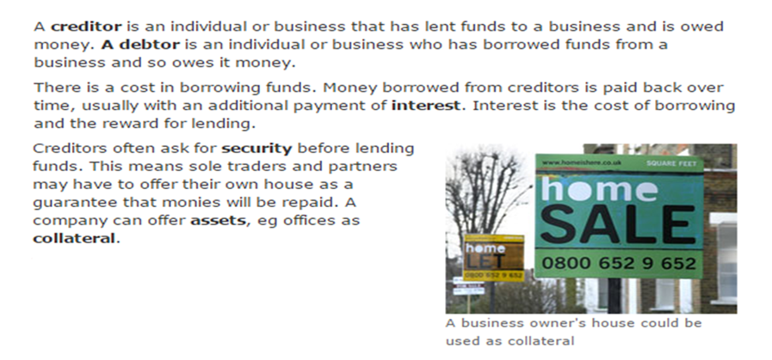
What does a business need to apply for a loan?
Before a business can get a loan, the bank will look at some of the following:
- Credit Rating
- Amount and Duration of loan
- Purpose of the loan
- Ability to meet repayments
- Business Plan
- Collateral
Sources of Finance
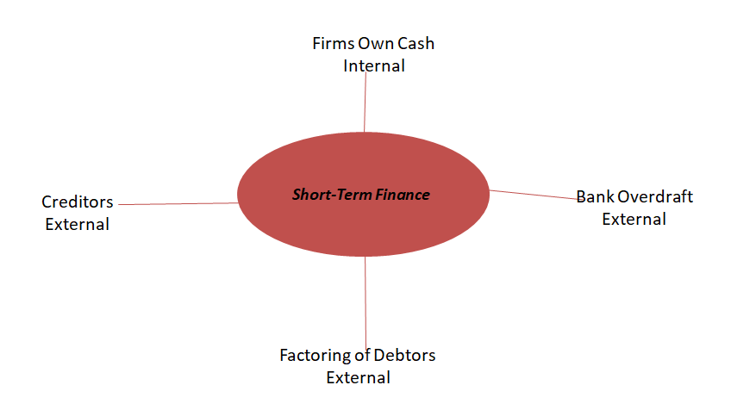
Creditors/Buying on Trade Credit: This is when a business buys a good now but pays for it at a later date once all stock has been sold. It means that they will have access to stock that they can sell immediately that they may not have been able to afford up front.
Factoring of Debtors: This is when a business knows that they will be paid money at a later date by a debtor, and so will sell off this date to a factoring company at a discount to get instant cash into the business.
Bank Overdraft: A bank overdraft lets you borrow money through your current account by taking out more money than you have in the account. There's usually an interest charge for this.
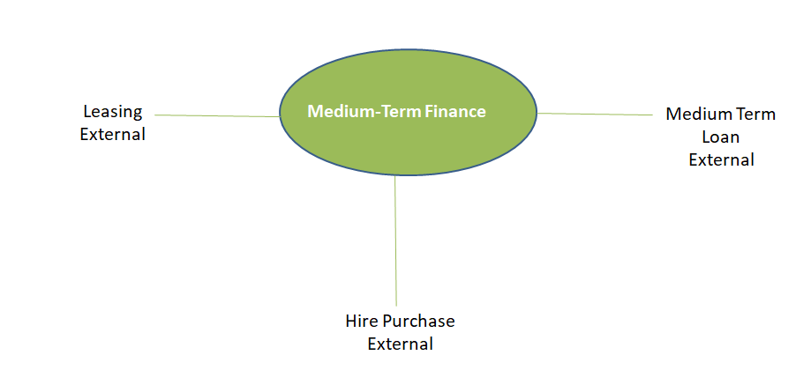
Leasing: Leasing is a medium term source of finance. It is like renting as you get use of the asset but will never own it. It is therefore cheaper than Hire Purchase.
Hire Purchase: Hire Purchase is a medium term source of finance. You pay for an asset in instalments and will only own the asset after the last instalment has been paid. It is more expensive than Leasing.
Medium Term Loan: This is a loan from the bank for between 1-5 years. You will have to also pay interest on this loan.

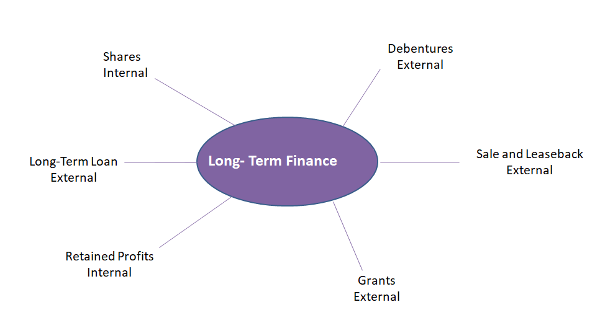
Long Term Sources Explained
Shares: The firm sells shares to the public and uses the cash to pay for things.
Long-Term Loans: This would be like a mortgage over a period of over 20 years. Repayments would need to be paid with interest.
Retained Profits: This is placing profits back into the company.
Debentures: A certificate issued that is secured against a long term debt. Interest is also paid.
Sale and Leaseback: This is the selling of an asset and leasing back over time. The firm receives a large injection of cash and rents back the property.
Grant: This comes from the government. It is used to set up or expand the business. It does not have to be repaid as long as strict terms and conditions set out in the grant are met.

