Business Expansion

The growth of any business is called expansion. Management must make decisions as to how this expansion will take place and how it is to be financed.
This expansion may be ORGANIC or INORGANIC.
Organic Growth
Organic Growth is the natural expansion of a business as it makes profits and then ploughs these back into the business.
The profits retained by are used to buy machinery, equipment, premises, etc. Organic growth happens within the business & does not involve outside firms.
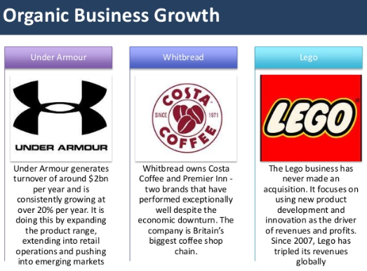

Organic Growth Strategies
Increase Sales on existing products:
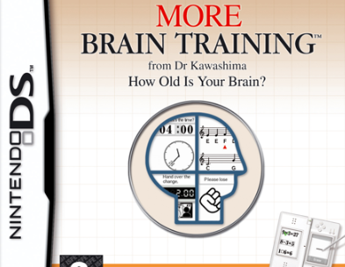
If the company sells more of its products they will have a larger profit. This can be achieved through better marketing and improving the product. It can also be achieved by finding a new target market or exporting to different markets. Example: Nintendo released the Brain Training game, this led to Nintendo appealing to a new target market of older people
New Product Development:
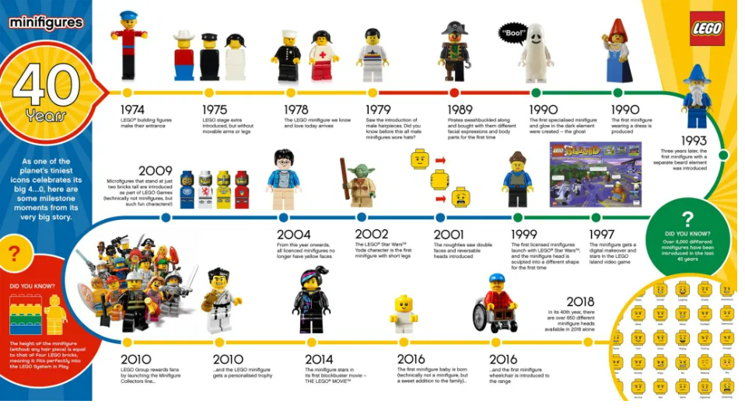
By adding to its product portfolio a business can increase its consumer base and invest into new markets. Exanple: Coca-Cola brought out Coke Zero in 2005 for a male alternative to Diet Coke as traditionally they shied away from that as an alternative to regular coke
Lego constantly brings out new products to the market.
Exporting:
Businesses only operating in the Irish market could consider expanding business operations to oversees, the major benefit being the increase in sales, but they would need to be aware of added costs, possible trade barriers etc..
Franchising:
A franchise is a licence agreement whereby the original owner of the company (franchisor) gives permission to other entrepreneurs (franchisee)to copy their business idea in return for a fee. Failure to adhere to the agreement of the licence may result in termination of the franchise agreement. Example: McDonalds.
Benefits of Franchising as a form of Expansion- if question comes up- answer from point of view of franchisor- NOT FRANCHISEE!!!!
- It is a form of expansion which requires low capital investment by the franchisor as the capital used to expand the business comes from franchisees. The franchisee must purchase the building, equipment etc.. for the franchise, not the franchiser
- Franchising permits a more rapid expansion. By using the franchisees' capital, the franchisor is able to establish a large number of outlets in a short period of time. Rapid expansion can be achieved without incurring the overheads and costs associated with opening company-owned restaurants
- The franchise can benefit from economies of scale with suppliers and obtain discounts from bulk orders. This can lead to an increase in profit revenue
- A franchise system requires less management than a company owned chain of restaurants. Hiring, training, motivating and retaining competent staffing are all functions handled by the franchisee, not the franchisor
- There is low risk to the franchiser as should the franchisee not adhere to the conditions of the contract it could be cancelled. This can help prevent damage to the franchisers reputation- e.g. unclean tables or poor delivery service
Drawbacks of Franchises as a Method of Expansion
- Control is lost over the day-to-day management of the franchise businesses. It can be difficult to oversee all outlets on a day-day basis and ensure they are implementing the licence agreement properly
- The reputation of the whole business could be affected by the actions of one franchisee /poor quality standards/staff problems
- There are increased costs to ensure likelihood of success, such as investment in training that can be expensive and time consuming
- The franchiser needs to regularly monitor the franchisee to ensure standards are maintained. This can take away time from the franchiser’s operations
Inorganic Growth
Takes place when a firm takes an interest in buying other firms.
Reasons for this are as follows:
- Owners wish to expand the firm at faster rate
- The business is at a standstill at present & expansion will help it prosper
The main INOrganic Growth Strategies are:
- Acquisition/Takeover
- Merger
- Strategic Alliance

- Acquisition/Takeover
This is where one company takes over another by buying 51% of its shares. a result they gain the major control of firm. The seller will want as much as possible for the business & the buyer will want to pay as little as possible. The actual price will be somewhere in between.
The company that has the majority shares is called the holding company, and the company that has been acquired is called the subsidiary. Some takeovers can be hostile, when the directors of a takeover refuse to sell, or friendly.
Example- In 2012, Facebook acquired Instagram for 1 billion dollars.
Benefits/Advantages
Increased Sales/Acquire new products
An acquisition leads to the business acquiring new products and increasing their product portfolio. This can result in increased sales and profits. Apple’s takeover of Beats by Dr. Dre resulted in Apple now having Beats headphones as part of their product portfolio.
Market Share
One advantage of an acquisition is that the business gains instant market share in an industry. Apple became a market leader in the headphones industry and music streaming industry after acquiring Beats by Dr.Dre.
Acquire expertise/achieve synergies
The business acquires the expertise of the staff from the company they have purchased. Apple gained the expertise of the staff at Beats by Dr.Dre. This helped Apple develop Apple wireless headphones and the Apple music streaming service.
Risks/Disadvantages
High cost associated with an acquisition: An acquisition involves one business buying 51% of the shares in another company. This is an expensive method of expansion. There are also vast legal fees. e.g. Apple paid $3 billion dollars to purchase Beats by Dre.
Industrial Relations issues/ Conflict
An acquisition can be hostile. This is when a large percentage of shareholders are against the takeover. This can lead to conflict. If the acquisition leads to redundancies it can cause industrial relations problems.
- Strategic Alliance
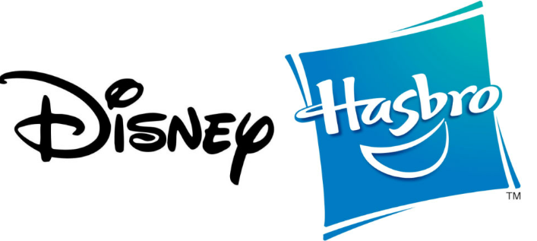
This involves two or more independent firms combining their skills & resources in a particular line of activity for mutual benefit.
Alliances are popular because the companies co-operate with each other in relation to market information, new technology, human resources etc. Both parties work together while maintaining their separate legal entities and return back to their original business once the alliance has ended.
Example: Disney and Hasbro have a strategic alliance for Marvel and Star Wars merchandise
Advantages/Benefits
• It is a voluntary agreement and each party remains a separate legal entity meaning if it does not work out, they revert back to their original business
• Skills and risks are shared so both parties’ gain. New skills can be taken back to the organisation and implemented.
• Access to an established network of suppliers and distributors.
• It is a quick low-cost way to expand into foreign markets and the partners benefit from the sharing of business networks.
Risks/Disadvantages
• Corporate secrets/competitive advantages can be lost.
• Alliances may not be equal. One side may contribute more than another.
• Alliances are temporary so careful change. management is needed to ensure that full- time staff are not alienated as they will be relied on when the alliance is over.
- Merger
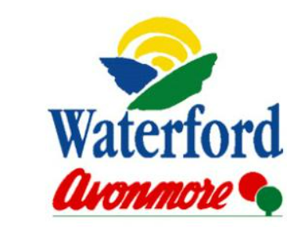
Where two firms come together by mutual agreement to run their businesses as one. A new legal entity is formed. A merger is very like a takeover, but the main difference is that a merger is usually more friendly arrangement. There is hopefully synergy- as both businesses do better together than they would on their own.
Example- Glenbia PLC was founded following the merger of Avonmore and Waterford Foods to grow the scale of their operations
Benefits/Advantages
- It is a defensive strategy as the merger may involve diversification into new product areas, which reduces the risk of the firm ‘having all its eggs in the on basket’.
- It is a quick form of business expansion unlike organic growth.
- Costs will be lower if merging with another business -economies of scale/sharing of costs/resources.
- Firms can access new technology and new markets quickly
Risks/Disadvantages
- Mergers can cause industrial relations problems. e.g. Redundancies could result, which could cause industrial relations disputes.
- Different organisational cultures can lead to conflict between competing management teams who are used to their own work practices and management styles and systems. This may cause a lack of co-operation within the new larger merged entity, leading to poor management decision making.

Reasons for Expanding
Defensive Reasons
Economies of scale/Reduce Costs: As a business gets bigger, it can benefit from economies of scale. It will have greater buying power and may receive large discounts from suppliers resulting in lower business costs. It can then offer customers lower prices which can increase profits. Ryanair is expanding rapidly and was recently able to order 100 jets from Boeing at discounts of nearly 40%.
Diversification: This involves firms entering new markets, spreading risk, creating new products or buying businesses in an unrelated market in order to reduce dependency on one product or market. Sony have diversified with different products including TV’s, music, gaming etc.. The large size and financial resources of Tescos means that it has been able to diversify into other products such as Mobile Phones, insurance, petrol, credit cards and banking.
Protect Raw Materials: Safeguarding sources of raw materials or channels of distribution -e.g. Vodafone buying chains of mobile phone retailers
Aggressive Reasons
The elimination of competition: A firm may buy out a competitor in order to enter a new market (Tesco's purchase of Quinnsworth) or to increase its market share
To increase profits: By expanding firms increase their talent, product range and sales, they reduce their costs, make better use of their resources and make more money. Arnotts Department store in Dublin earns more profits that small independent retail outlets.
To acquire new assets: A firm may have assets that are not fully used, e.g. people, land equipment or cash. As part of a larger firm, better use may be made of these assets. As a result firm can become more profitable. An example would be Adidas acquiring Reebok for 3.1 billion dollars in 2006
Synergy: This occurs when the sum of two or more firms joined together will be greater than the efforts of the firms operating separately. The merging of Irish Life and Irish Permanent meant that Irish Life gained access to a large customer base that would have to take out life insurance when taking out loans for their homes
Psychological Reasons
Challenge and Ambition: In this case, the businessperson needs to grow the business to satisfy their needs for esteem and self-actualisation. Richard Branson will always be associated with the growth of Virgin from a record store to a global brand capable of selling a wide variety of products
Finance for Business Expansion
Sources of Finance- Think back to long term finance in 5TH Year
1. Retained Earnings
Are profits, which are ploughed back into the business to create growth? This form of finance is suitable for organic growth as the pace of the expansion can be matched to the funds available. They are used to finance the purchase of new buildings or equipment. They have no direct cost for a company but take a long time to build up.
2. Equity Capital
This is money imputed into the firm by the individual shareholders. As the firm makes money, the shareholders receive a % dividend on their investment. However if the firm’s profits are low, the individual dividend will be low.
3. Loan/Debt Capital
Is the long-term finance provided by financial institutions? Long-term loans are called debentures. When applying for a loan to finance expansion, a company has to supply the bank with accounts showing the present state of the business. Also needed are cash flow forecasts, costings, and research.
Information needed before any loan is granted includes:
- Purpose of loan
- Capacity to repay
- Amount of loan
- Security offered
- Duration of loan
4. Grants
Enterprise Boards and provide finance to help businesses grow and develop with capital that they will not have to pay back to get the business developing and growing
*Evaluate Debt and Equity Capital as sources of finance for Business Expansion*
 | Debt Capital | Equity Capital
Amount | Large amounts available | Large amounts available
Control | No direct loss in control, however assets may be used as collateral | Control may be lost due to the issuing of shares as shareholders now have a say in running your business
Cost | Loan interest must be repaid, regardless of how profitable the business is | Can be cheap as only pay dividends when profits made. Businesses must be careful as shareholders may go elsewhere if they do not get a sufficient return
Risk | If a business cannot make their repayments, creditors may seek for the business to be wound up to pay debts | A business that uses more equity than debt for finance is lowly geared, and so less likely to become bankrupt
Collateral | The business will have to provide | No collateral provided
Tax | Interest payments are tax deductible and can be used to reduce tax liability | Dividends paid to shareholders are not tax deductible

2020 Question and Solution
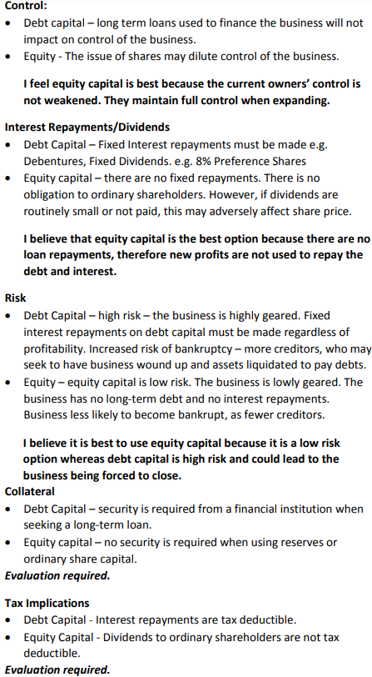
Evaluation of Debt and Equity Capital as sources of finance
In my opinion, to decide if a business should seek more capital investment should depend on how highly geared it is. Cash flow is essential for business operations, so if more debt decreases cash flow, I would choose equity to expand even if it means losing more control in the business.

Implications of Business Expansion
Organisational structure
In the short term, an expanding business may retain its organisational structure – especially if it is expanding organically. However, it needs a clear line of authority and a definite chain of command to manage the changes.
In the long term, the business is likely to need some re-structuring to manage its expanded size efficiently. An expanding business may need to change from a functional structure to a product or geographical structure. It is easier for top management to monitor individual units when they are separated into distinct divisions. Also, product or geographical divisions can respond more quickly to conditions in their own markets.
Product mix
In the short term an expanding business develops products to suit a range of market segments. There should be an increased product mix as the business grows.
In the long term there will also be a wider product mix because of continuing market research and product development. In an expanding business, the product mix could grow beyond the business’ original core products. In the long term, the business will have to decide on new products, markets, promotion, distribution, brand names and possibly the company’s identity.
Profitability
In the short term, profits might decrease as the business absorbs the cost of expansion, e.g. researching, developing and launching a new product or acquiring a company.
In the long term profits should increase with the success of expansion. These profits are usually the result of economies of scale and the increased market power that the expanded company will have.

Employment
In the short term, people will need to be trained, promoted, recruited and perhaps, made redundant. In the short term employment will increase as the business grows. More staff will be needed to cope with the greater work load.
In the long term an expanded business will inevitably employ more workers. However, the workforce may have experienced some losses through rationalisation – especially following a merger or takeover.
Customers
In the short term, customers will enjoy a bigger range of products in a business with lower prices due to economies of scale
In the long term, although customers enjoy more products, they may lose the personal service that was offered by small businesses and so may go elsewhere

IMPORTANCE OF IRISH BUSINESS EXPANSION
Domestic market
1. Employment increases meaning more people paying taxes and buying goods and services in an economy.
2. As business expands, it gets stronger making it possible to survive and compete against other businesses in the market.
3. Increased competition with Irish and European firms make it possible for higher quality good be produced
4. Larger firms benefit from economies of scale. This can increase competitiveness as lower prices can be passed onto consumers.

Foreign market
1. Increased exports improves Ireland’s Balance of Trade. Ireland can operate at a surplus meaning more jobs and increase in standard of living.
2.Diversification achieved as business products are not reliant on just the home market. If one market has low turnover, another market can compensate.
3. More jobs for Irish people who work in business’s that export abroad
4. Expansion fosters positive international relations between Ireland and the rest of the world

How expansion can be restricted
Businesses need to be aware that wary that some expansions may be restricted if the Irish government or EU believe that it is not in the best interest of consumers.
In Ireland, restrictions on expansion is regulated by the CCPC, where mergers and takeovers above a certain value are examined, and if it believed that it will have a negative effect on the Irish Market, (e.g. Monopoly), it may be denied
In the EU, under European competition law, the European Commission appoints a commissioner for competition to investigate larger mergers and takeovers. If they are not in the best interest of consumers, they will be denied- for example, the EU Commission blocked a proposed takeover of Aer Lingus by Ryanair as it would result in a dominant business in the airline market.

