Borrowing Money
- Why Borrow?
- The Wise Borrower
- The cost of borrowing
- Sources of Finance
- What happens if I can’t repay my loans?

Why Borrow?
Sometimes we don’t have enough money in savings to pay for what we need. For example, we may not have enough money to pay our bills while waiting for wages or salaries to come in. We may also decide we need to borrow a bigger sum for a Capital item like a house or car. Therefore we have to borrow money so we can afford these items.

The Wise Borrower
Like in our study of The Wise Consumer, a wise borrower will also ask themselves the following questions:
- Do I really need the product I am borrowing for?
- Can I afford the repayments?
- Have I checked different financial institutions like banks and credit unions?
- What will the interest be?
- What will happen if I can’t pay the money back?

The Cost of Borrowing
- Flat Rate vs APR when borrowing
The full annual rate of interest paid on a loan is known as the APR (Annual Percentage Rate). The APR is calculated each year only on the part of the loan outstanding (What’s left over). This is the true rate of interest and you will always here it on ads for banks.
Some institutions offer a loan at a flat rate, meaning the borrower is charged a fix rate of interest until the loan is paid off. This can be more expensive than APR as it does not take into account that the loan goes down in value each year.
Working out APR and Flat Rates of Interest
Example:
Sum of money borrowed is €3000 and is to be repaid over 3 years at 1% interest per annum. We will assume one payment, including interest, is made at the end of the year.
Note that we will always pay €1000 a year back to the bank as it is a €3,000 loan over 3 years with interest.
1% on €3000 over 3 years for Flat and APR
Flat Rate APR Rate
 | Balance | Interest  (Starting balance €3,000 x 1%) | Total Payment | Balance | Interest  (On the balance each year) | Total Payment
Year 1 | €3000 | €30 | €1,030 | €3000  (€3,000 x 1%) | €30 | €1,030
Year 2 | €2000 | €30 | €1,030 | €2000  (2,000 x 1%) | €20 | €1,020
Year 3 | €1000 | €30 | €1,030 | €1000  (€1,000 x 1%) | €10 | €1,010
Total | 0 | €90 | €3,090 | 0 | €60 | €3,060

Practice Questions
Question 1
You are asked to recommend an interest rate to your friend based on the following figures. Which would you recommend and why?
Sum of money borrowed is €2000 and is to be repaid over 4 years at 1% interest per annum. We will assume one payment, including interest, is made at the end of the year.
 | Balance | Interest | Total Payment | Balance | Interest | Total Payment
Year 1
Year 2
Year 3
Year 4
Total
Flat Rate APR Rate

Question 2
You are asked to recommend an interest rate to your business teacher based on the following figures. Which would you recommend and why?
Sum of money borrowed is €5,000 and is to be repaid over 5 years at 1% interest per annum. We will assume one payment, including interest, is made at the end of the year.
Flat Rate APR Rate
 | Balance | Interest | Total Payment | Balance | Interest | Total Payment
Year 1
Year 2
Year 3
Year 4
Total

Question 3
You are asked to recommend an interest rate to your aunt based on the following figures. Which would you recommend and why?
Sum of money borrowed is €1,000 and is to be repaid over 5 years at 3% interest per annum flat, or 3% for the first 3 years and 4 % for the remaining two APR. We will assume one payment, including interest, is made at the end of the year.
 | Balance | Interest | Total Payment | Balance | Interest | Total Payment
Year 1
Year 2
Year 3
Year 4
Total

Sources of Finance
When choosing to borrow, a household or business need to know clearly what they are borrowing money for. Once they have established they need to borrow, they must then look at what their finance options are.
Remember in First Year Expenditure, we looked at both Current and Capital Expenditure:
Current Expenditure: This is day-day spending. We will generally by these items for the short term. Examples include food, groceries, credit, Spotify subscription etc...
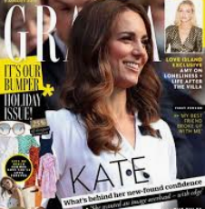
Capital Expenditure: This is spending for the long term such as buying a house or car. These items that we buy will last a long time.
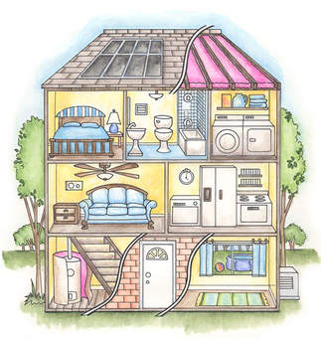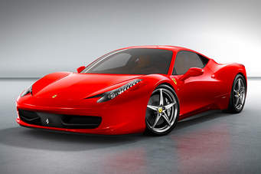

Therefore we classify our current needs as short term, and our Capital needs as medium and long term.
Current expenditure is known as short- term (up to a year)
Capital expenditure is known as medium- term (will be replaced every 1-5 years) or long- term (for the long term future) expenditure

Short Term Finance
Bank Overdraft
This is an agreement between the bank and the consumer that allows the current account holder to spend more money than they have in their account but only up to an agreed limit. A small amount of interest is charged provided money is repaid quickly. An individual has to be careful to make their repayments on time or this could affect their credit rating for the future.
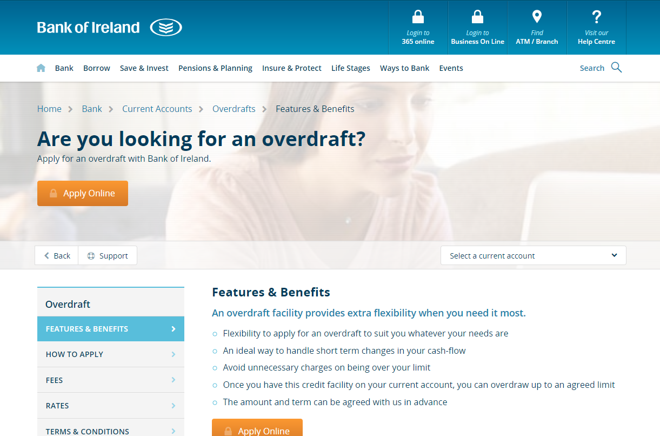

Credit Cards
These are small plastic cards issued by a bank, building society, etc., allowing the holder to purchase goods or services on credit. They can be used either in store or online. You cannot exceed the limit agreed with your financial institution or your credit card will max out. You must also be aware of the interest.
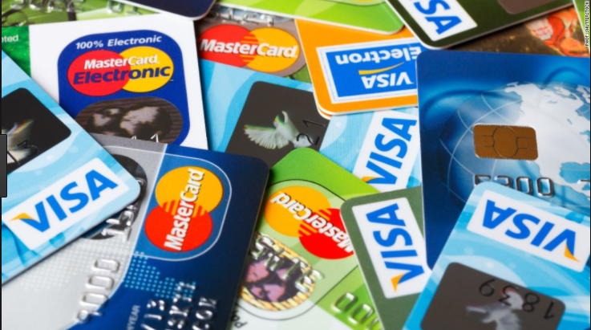
Sample Credit Card Statement
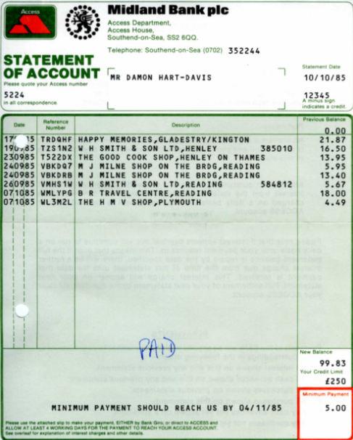
10/10/16
15/10/16
Total Transactions for the Month
Credit Limit
Minimum Repayment to be paid
If the minimum payment is not paid, there will be a high amount of interest charged.
Charge Cards
This is like a credit card for use with an account but unlike a credit card the balance must be paid in full when a statement is issued. Interest can be very high if the bills are not repaid in full and many people end up in serious debt using a charge card.
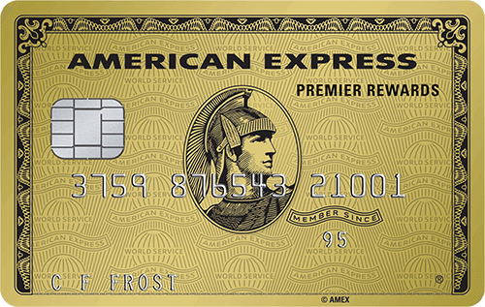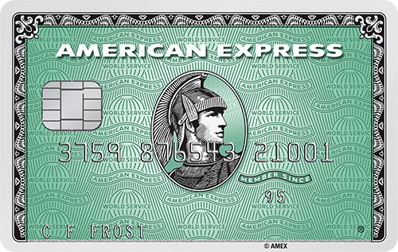

Other Short Term Sources of Finance
Money Lenders- Will see these often on TV, be careful with the high interest rates
Short Term Loan- Given by the bank, usually for a small amount up to a year. Interest will be attached to this
Buying on Credit- Allow people to buy the products immediately but pay for it at a later date

Medium Term Sources of Finance
A Term Loan- This is a loan payable over a given time period. The customer pays in instalments and there will usually be collateral (something of value, eg. House/factory) against the loan. A loan application form will be filled out for this purpose.
Leasing- Like renting- you never own the product and return when you are finished. Cheaper than hire purchase, but remember that you never own the product.
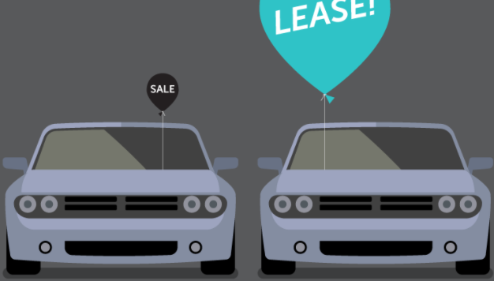
Hire Purchase- You are hiring or renting the item and only own it when the last payment is made. You fill out a hire purchase agreement and make repayments with interest. The customer then pays back to the finance company until the last payment is made.
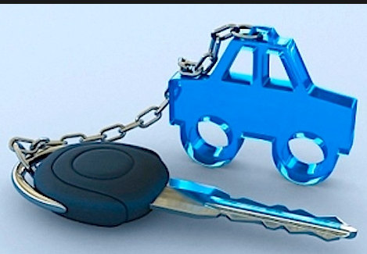
Think of the chain restricting your ownership until the last payment.
Borrowing v Hire Purchase
Billie Eilish wishes to borrow in order to purchase a drumkit for her band worth €6000. She has the following options:
- Hire Purchase- €500 deposit and 36 instalments of €150 each
- Loan- €6000 @ 7.5% APR over 3 years, with the loan to reduce by €2000 each year
Calculate the total cost of each option showing your workings.
Which would you recommend and why?

Long Term Finance
A Mortgage- Traditionally offered by building societies, this is generally used as a long term loan to purchase property. Interest will also be paid at a fixed or variable rate. The typical duration for a mortgage is 20-35 years. The house is used as collateral (security) in case you cannot meet the repayments and will be repossessed and sold by the lender to get their money back
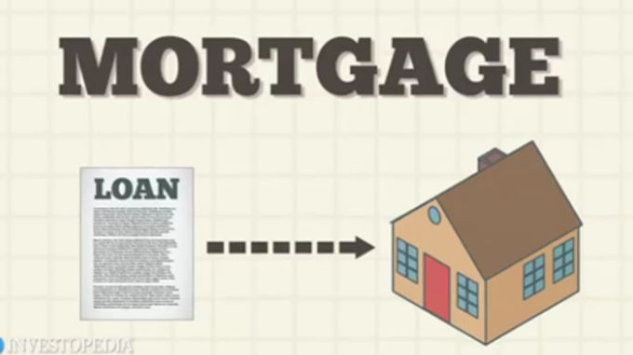
What if I can’t repay my loans?
Anybody who cannot repay their loans will be declared bankrupt. This means that an individual can no longer afford their repayments.
The consequences for being declared bankrupt are as follows:
- Your credit rating will suffer greatly and it will prevent you from ever borrowing again
- Your possessions can be repossessed- you can lose every personal asset to pay off debts

